
College of Computing and Information Sciences
Department of Computing and Information Sciences
CSDS4105 B-Tech Course Project I
Final Review Report

Hybrid Ensemble Learning with PSI and DRZ for Lung Cancer Prediction

Submitted By:
Al-Shaima Salim Al-Mamari – 12s21196
Saba Mahmood Alnaamani - 16s2176
Hager Ahmed Al-Dhahli - 16j2139

Supervised by:
Dr. Houda Saif Humaid AL Ghafri

Date of Submission: 11 April 2026
Academic Year: Fall Semester 2025-2026 Semester: 1

Declaration
(Semester - Fall, Academic Year 2025-2026)
To: Dr. Muna Saif Humaid Al Rahbi
Head of Department of Computing and Information Sciences
Thru: Supervisor Name
Supervisor

I/we, the undersigned Al-Shaima, Saba, Hager declare that:
1) the submitted work is my/our own work.
2) I/we understand the consequences of committing plagiarism.
3) I/we understand the evaluation criteria used to assess my/our work.

Student Signature: ID: 12s21196 Date:16/March/2026


Student Signature: ID: 16s2176 Date: 16/March/2026

Student Signature:  ID: 16j2139 Date: 16/March/2026

Acknowledgement
We would like to express our sincere gratitude to our supervisor, Dr. Houda Saif Humaid Al Ghafri, for her continuous guidance, valuable feedback, and support throughout the development of this research project. Her advice and encouragement played an important role in improving the quality of our work and helping us overcome many challenges during the research process.
We would also like to extend our appreciation to Dr. Yusra Mohammed Salim Al Roshdi, the Head of the Artificial Intelligence and Data Science specialization, for her support, encouragement, and academic guidance throughout our study.
In addition, we would like to thank the Department of Computing and Information Sciences at the University of Technology and Applied Sciences for providing us with the academic environment and resources needed to complete this project successfully.
We are also thankful to our colleagues, friends, and family members for their encouragement, motivation, and continuous support throughout this journey.
Finally, we appreciate everyone who contributed directly or indirectly to the success of this project.

Abstract
Lung cancer remains one of the leading causes of cancer-related mortality worldwide due to late diagnosis and the difficulty of detecting the disease during its early stages. Recent studies show that lung cancer risk is influenced not only by smoking behavior but also by environmental exposure, and lifestyle-related conditions. Early prediction of lung cancer risk using Artificial Intelligence (AI) and machine learning techniques can support healthcare professionals in identifying high-risk patients and improving early clinical decision-making.
This project proposes a hybrid ensemble machine learning model for explainable lung cancer risk prediction using structured clinical and environmental dataset collected from publicly available Kaggle sources. The study applies several machine learning algorithms, including Support Vector Machine (SVM), Random Forest (RF), and XGBoost as base classifiers within a stacking ensemble architecture, while Logistic Regression (LR) is used as the meta-learner. In addition, a Soft Voting ensemble model is implemented for comparative evaluation.
Several preprocessing techniques are applied to improve data quality and model performance, including duplicate removal, categorical encoding, feature scaling, correlation analysis, mutual information analysis, and stratified train-test splitting. The project also integrates Patient Similarity Index (PSI) using Mahalanobis Distance to identify patients with similar patient risk profiles and improve prediction understanding. Furthermore, Decision Reliability Zones (DRZ) are used to classify prediction confidence levels and support safer healthcare decision-making.
To improve model transparency and interpretability, Explainable Artificial Intelligence (XAI) techniques such as SHAP are incorporated to explain feature contributions and identify the most influential factors affecting lung cancer prediction. Counterfactual explanation is also applied to provide actionable recommendations by identifying minimal changes that may reduce predicted lung cancer risk.
The proposed model is evaluated using several classification metrics, including Accuracy, Precision, Recall, F1-score, and ROC-AUC, with special focus on Recall to reduce false negative predictions in healthcare diagnosis. The expected outcome of this research is the development of an accurate, explainable, and interpretable lung cancer prediction model capable of supporting early healthcare decision-making and improving understanding of important clinical and environmental risk factors associated with lung cancer. In addition, this project supports the digital healthcare and innovation goals of Oman Vision 2040 through the application of AI and data science technologies in healthcare systems.

Table of Contents
Table of Figures 7
Table of Tables 7
Abbreviations 8
CHAPTER 1: INTRODUCTION 9
1.1 Problem statement 10
1.2 Project objectives 10
1.3 Research Questions 11
1.4 Project Scope and Delimitations 11
1.5 Alignment with Oman Vision 2040 11
1.6 Academic, Scientific, and Innovation Significance 12
1.7 Expected Outcomes & Contribution 12
1.8 Draft project plan (Gantt/timeline) 13
CHAPTER 2: LITERATURE REVIEW 15
2.1. Methodology of the literature review 15
2.2. Foundational Concepts and Theoretical Framework 16
2.3. Critical Analysis and Synthesis of Related Studies 17
2.4. Research Gap 35
2.5. Conclusion 36
CHAPTER 3: RESEARCH METHODOLOGY 37
3.1 Research Design 37
3.2. Methodology 38
3.2.1 Data Collection 38
3.2.2 Model Development 38
3.2.3 Tools and Technologies 39
CHAPTER 4: PREPROCESSING DATASETS 40
4.1 Introduction 40
4.2 Descriptive and Exploratory Data Analysis (EDA) 41
4.3 Data pre-processing 45
4.3.1. Data Transformation 45
4.3.2. Data Cleaning 46
4.3.3. Data Reduction 48
4.4 Conclusion 50
CHAPTER 5: MODEL DESCRIPTION 50
5.1 Overview of the Selected Model / Algorithm 50
5.2 Model Architecture / Structure 51
5.3 Implementation Plan 56
5.4 Evaluation Methods 57
5.5 Summary 58
CHAPTER 6: CONCLUSION AND FUTURE WORK 58
6.1. Conclusion 58
6.2. Future Work (Sem 2 work) 58
APPENDICES 60
REFERENCES 78

Table of Figures
Figure 1.1 Project Plan (Gantt/Timeline) 14
Figure 4.1: Age Distribution of Patients……………………………………………………….41
Figure 4.2: Class Distribution Analysis……………………………………………………………………….
Figure 4.3: Correlation Heatmap of Final Prediction Features……………………………………………………………………………41
Figure 4.3.1: Encoding…………………………………………………………………………………………………………………………..45
Figure 5.1 illustrates the overall architecture of the proposed hybrid ensemble lung cancer prediction framework……………………………………………………………………………………………………………………………………………51
Figure 5.2 presents the stacking ensemble structure used in the proposed framework………………..……..51
Figure 5.3 shows the PSI and DRZ reliability workflow integrated into the proposed framework…..…….51

Table of Tables
Table 1: literature review 17
Figure 5.3 shows the PSI and DRZ reliability workflow integrated into the proposed framework……………52

Abbreviations
AI — Artificial Intelligence
AUC — Area Under the ROC Curve
COPD — Chronic Obstructive Pulmonary Disease
DRZ — Decision Reliability Zones
EDA — Exploratory Data Analysis
EHR — Electronic Health Records
IQR — Interquartile Range
LR — Logistic Regression
ML — Machine Learning
PSI — Patient Similarity Index
RF — Random Forest
SVM — Support Vector Machine
XAI — Explainable Artificial Intelligence
XGBoost — Extreme Gradient Boosting

CHAPTER 1: INTRODUCTION
Background
Lung cancer remains one of the most frequently diagnosed cancers and continues to be the primary cause of cancer-related mortality worldwide [1],[3]. The disease develops as a result of abnormal and uncontrolled growth of cells in the lung tissues, leading to the formation of tumours that may metastasize to other organs [3]. A major clinical concern is that early-stage lung cancer often progresses without obvious symptoms, causing many patients to be diagnosed only at intermediate or advanced stages [1]. The five-year survival rate can reach up to 90% for early-stage cases but drops to less than 10% for stage IV [4]. Beyond traditional risk factors such as tobacco smoking, recent evidence highlights a rising incidence among non-smokers, emphasizing the role of environmental pollutants, such as particulate matter (PM2.5), along with genetic predispositions [2], [4].
The availability of large amounts of healthcare data has created opportunities for improving disease prediction. However, traditional statistical methods often rely on assumptions that may not fully represent real-world medical data. In contrast, Artificial Intelligence (AI) and machine learning (ML) models, such as Random Forest (RF) and XGBoost, have shown strong performance in identifying complex patterns. Several studies have reported improved predictive performance using these models [5], [6],[7],[8]. These models, including Random Forest, Support Vector Machine, and Logistic Regression, are widely used in medical prediction tasks due to their ability to handle complex and high-dimensional data [9], [10], [11]. By leveraging structured clinical datasets, these techniques can support more accurate risk prediction and assist in clinical decision-making [3].
There are still some limitations and research gaps in previous studies. Many studies use small datasets with only a few hundred records, which may make the models less reliable for real-world use [9], [10], [11]. In addition, some advanced machine learning (ML) and deep learning models are difficult to explain, which makes doctors less likely to trust and use them in clinical decisions [14], [15]. Another important gap is that only a few studies have compared several ML models using more than one structured clinical dataset to check their consistency, reliability, and ability to work well on new data.
To address these limitations, this project focuses on developing and evaluating a lung cancer risk prediction framework using a publicly available dataset from Kaggle. The study applies and compares multiple machine learning classification models and integrates ensemble learning, patient similarity analysis, reliability assessment, and explainability techniques to improve prediction performance, interpretability, and reliability. This approach also supports the goals of Oman Vision 2040 by applying AI and data science techniques to healthcare-related research [16], [17].

Problem statement
Lung cancer is one of the leading causes of cancer-related mortality worldwide, primarily due to late-stage diagnosis caused by the asymptomatic nature of the disease in its early stages. This significantly reduces treatment effectiveness and increases mortality rates [1], [2]. Moreover, recent epidemiological evidence shows that lung cancer is no longer restricted to smokers, as environmental factors such as air pollution, along with genetic susceptibility and lifestyle factors, contribute significantly to increasing cases among non-smokers [18], [19].
Many existing lung cancer prediction studies focus mainly on classification performance without sufficiently addressing prediction reliability and interpretability. In addition, some studies rely on individual patient information without considering the similarity between patient profiles, which may limit the understanding of prediction reliability. Another limitation is that some prediction systems provide a final prediction without indicating the confidence or reliability of the decision [21], [9].
Moreover, explainability techniques such as SHAP are not consistently integrated into lung cancer prediction frameworks, making it difficult to understand how different features contribute to the prediction. In addition, relying mainly on accuracy may not provide a complete evaluation of a binary classification model, particularly when false negative predictions are important to consider. Therefore, there is a need for a prediction framework that combines machine learning models with ensemble learning, patient similarity, reliability assessment, and explainability techniques [21], [13], [16], [12].
Another major issue is that most studies focus mainly on accuracy as the evaluation metric. However, in medical diagnosis, accuracy alone is not sufficient. Sensitivity (recall) is more important because failing to detect a real cancer case can lead to delayed treatment and serious health risks [16], [11], [22].
In addition, hyperparameter tuning are commonly applied, their effect on model stability and generalization is not always properly analysed. In some cases, synthetic sampling may also introduce bias if not validated carefully [6], [23].
Therefore, there is a need for more reliable lung cancer prediction models that are evaluated using clinically meaningful metrics, evaluated using different train-test configurations, and designed to improve generalization and real-world applicability.

Project objectives
- RO1: To develop a hybrid ensemble ML model for lung cancer risk prediction using the selected dataset for accurate risk classification, in alignment with the healthcare and innovation goals of Oman Vision 2040.

- RO2: To improve lung cancer prediction performance and confidence using Patient Similarity Index (PSI), Decision Reliability Zones (DRZ), and SHAP techniques.
- RO3: To support early healthcare decision-making by providing a prediction model that assists healthcare professionals in identifying high-risk lung cancer patients.

Research Questions
- RQ1: To what extent can a hybrid ensemble machine learning model predict lung cancer risk using the selected dataset?

- RQ2: How can PSI, DRZ, and SHAP techniques be integrated to improve prediction performance, interpretability, and confidence in lung cancer risk prediction?

- RQ3: To what extent can the proposed prediction model support early clinical decision-making by assisting healthcare professionals in identifying high-risk lung cancer patients?

Project Scope and Delimitations
The scope of this project is to develop and evaluate machine learning models for lung cancer risk prediction using a single publicly available dataset obtained from Kaggle. The dataset will be cleaned, preprocessed, analyzed, and prepared for machine learning implementation [24]. The study will implement Logistic Regression as a baseline model, along with SVM, Random Forest, XGBoost, Stacking Ensemble, and Soft Voting for comparative evaluation.
The project will also integrate PSI and DRZ to investigate patient similarity and prediction reliability, respectively, together with SHAP and Counterfactual Explanations for model interpretability [2], [4].
The study is an academic research project and is not intended for direct clinical diagnosis, treatment decisions, or immediate deployment in hospital software systems.

Alignment with Oman Vision 2040
This project is aligned with the “Health” pillar of Oman Vision 2040, which aims to build a modern and integrated healthcare system that meets international standards [16, 17]. This alignment is important for reducing the economic and social impact of chronic diseases on Oman’s healthcare system [15]. The study also highlights the effect of environmental factors, such as air pollution, on lung cancer risk, supporting national goals related to environmental protection and public health [26].
In addition, the research supports national development by applying AI and data science techniques locally, helping to improve skills in Fourth Industrial Revolution (4IR) technologies to solve public health challenges in Oman [17], [27]. By supporting local researchers through digital transformation, the project encourages innovation and helps academic research contribute to technology development and Oman’s goal of building a knowledge-based economy. Moreover, Sultan Haitham City includes 11 different healthcare facilities, which support the improvement of healthcare services and medical research in Oman [27].

Academic, Scientific, and Innovation Significance
This research makes a significant contribution to the fields of health informatics and predictive analytics by addressing the limitations of current lung cancer screening tools.
In academic terms, this study helps students and researchers understand how data science and ML can be applied to healthcare-related problem. It demonstrates how patient-related data, such as smoking habits, air pollution exposure, and health conditions, can be used to support early disease prediction.
The study also focuses on a comparative analysis of multiple ML models using different feature sets. Special attention is given to Recall rather than relying only on Accuracy. This is important in medical diagnosis because reducing false negatives (missed cancer cases) is more critical than overall accuracy. Missing a real patient can lead to delayed treatment and serious health risks.
From a scientific point of view, this project shows how medical data can be analyzed to discover hidden patterns and important risk factors related to lung cancer. It also highlights how AI can process large datasets to support faster and more accurate medical decision-making.
The study includes a detailed feature importance analysis to measure the contribution of different clinical and environmental variables in predicting lung cancer risk. This helps to understand how these factors interact and which ones have the strongest influence on disease development.
These findings improve the scientific understanding of lung cancer risk factors. In addition, the project links data science with preventive medicine by providing a structured model for AI-based health analytics. This may support the development of more interpretable and data-driven healthcare analytics approaches.

Expected Outcomes & Contribution
This research is expected to develop an accurate predictive model for lung cancer risk using ML techniques. It will also identify and rank the most important clinical and environmental factors that influence disease risk, helping doctors better understand key indicators.
The study will compare different ML algorithms to select the most effective model, with special focus on reducing false negatives to improve early detection. It will also incorporate a PSI to improve prediction by identifying patterns among similar patient cases, which can enhance the accuracy of risk estimation.
In terms of innovation, this study shifts from late diagnosis to early prediction. In addition, the model can be developed into a web-based application for both patients and doctors. Patients can enter basic health information to receive an early risk warning, while doctors can use the system to support diagnosis and decision-making. This makes the system more practical, interactive, and useful in real healthcare environments.
The study will also use XAI techniques, such as SHAP, to analyze and interpret the model’s decisions and to explain the impact of each clinical and environmental variable on the prediction results. This helps improve the transparency of the model and increases trust in its use in the medical field. Also, DRZ will be used to assess the confidence level.
Finally, this work supports Oman Vision 2040 by applying smart technologies in healthcare. It can help improve health services, reduce costs, and contribute to building a more advanced and efficient healthcare system in Oman.

Draft project plan (Gantt/timeline)
The project timeline and task distribution are illustrated using a Gantt chart to organize the research phases, monitor progress, and ensure the completion of the project within the planned schedule.
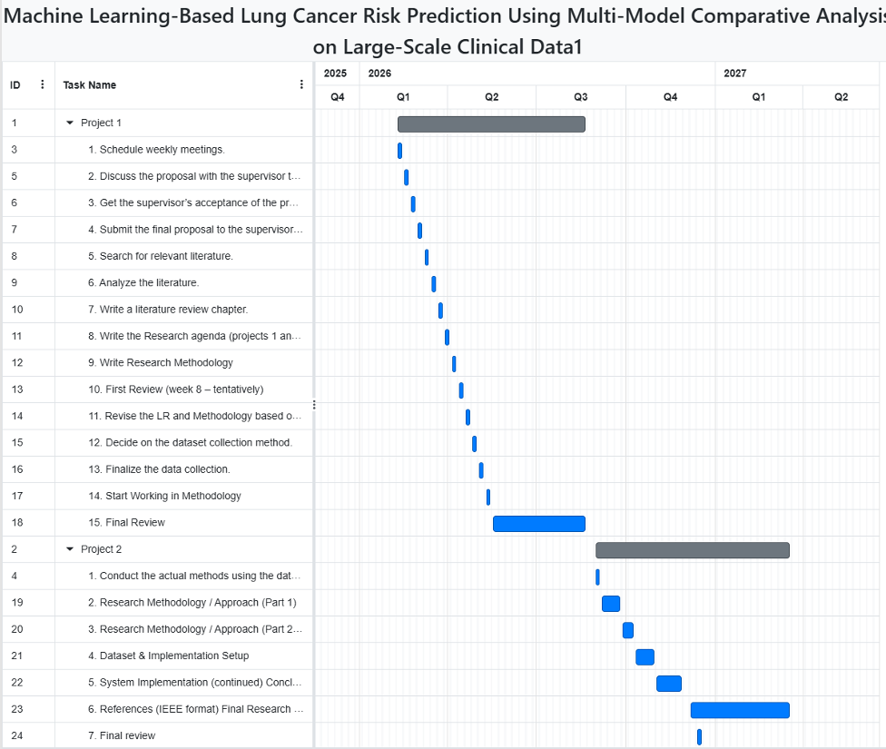
Figure 1.1 Project Plan (Gantt/Timeline)

CHAPTER 2: LITERATURE REVIEW
Introduction
This chapter presents a review of previous studies related to lung cancer prediction, ML applications in healthcare, ensemble learning, explainable artificial intelligence, and reliability-aware healthcare prediction systems. The purpose of this chapter is to understand the current developments in lung cancer prediction models, identify the most effective ML approaches used in previous studies, and analyze the strengths and limitations of existing research. The review also provides the theoretical and technical foundation for selecting suitable methods, datasets, and algorithms for this project.
In addition, the proposed framework supports the healthcare and digital transformation goals of Oman Vision 2040 through the application of AI-based healthcare prediction systems.
This chapter is organized into several sections. First, the methodology used for collecting and reviewing the literature is explained, including the data sources, search keywords, and data collection methods. Then, the chapter discusses foundational concepts and theoretical frameworks related to machine learning, healthcare prediction systems, ensemble learning, patient similarity analysis, and explainable artificial intelligence. After that, the chapter critically analyzes and compares related studies based on their methodologies, datasets, strengths, and limitations. A summary table of the reviewed studies is also provided. Finally, the research gaps identified from previous studies are discussed, followed by the chapter conclusion.

Methodology of the literature review
The literature review was conducted using different academic and scientific sources related to lung cancer prediction, machine learning, healthcare analytics, ensemble learning, explainable AI, and patient similarity analysis. The reviewed studies included journal articles, conference papers, review papers, healthcare reports, and publicly available datasets. Data sources used in the reviewed studies included publicly available datasets such as Kaggle datasets [24], [25], healthcare databases, electronic health records (EHR), epidemiological studies, and hospital clinical datasets [4], [11], [12], [17].
To identify relevant studies, several search keywords were used. These keywords included lung cancer prediction, machine learning, healthcare AI, ensemble learning, stacking model, Random Forest, Support Vector Machine, Logistic Regression, XGBoost, SHAP explainability, uncertainty-aware prediction, PSI, Mahalanobis Distance, and DRZ. These keywords helped identify studies related to healthcare prediction systems, explainable AI, and reliability-aware ML approaches.
The reviewed studies applied different methods for collecting and preparing data. Some studies relied on publicly available datasets such as Kaggle datasets for training and evaluating ML models [6], [18], [28], [30]. Other studies collected data from hospitals, healthcare institutions, electronic health records, and national healthcare databases [4], [11], [12], [17]. In addition, several review and epidemiological studies analyzed previously published healthcare data and cancer statistics to identify trends, limitations, and healthcare risk factors [1], [2], [3], [15]. The collected studies were analyzed and grouped according to common themes such as ML prediction models, ensemble learning approaches, explainable AI, patient similarity analysis, and reliability-aware healthcare prediction systems.

Foundational Concepts and Theoretical Framework
Data science and AI are widely used in healthcare systems to analyze medical datasets, identify disease patterns, and support healthcare decision-making. ML is a branch of AI that allows systems to learn from data and generate predictions without being explicitly programmed. In healthcare applications, ML models are commonly used for disease diagnosis, prediction, classification, and risk analysis [5], [10], [18].
This study is mainly based on supervised ML and classification techniques. In supervised learning, ML models are trained using labeled datasets where the target variable is already known. In lung cancer prediction systems, classification models are used to classify patients into categories such as lung cancer or non-lung cancer. This project specifically applies to binary classification techniques because the prediction output contains two classes representing positive and negative lung cancer cases.
Several ML algorithms are commonly used in healthcare prediction systems. Support Vector Machine (SVM) is a supervised learning algorithm that separates classes using optimal decision boundaries and is effective for handling nonlinear healthcare datasets [9], [30]. RF is an ensemble learning algorithm that combines multiple decision trees to improve prediction stability and reduce overfitting [18], [30]. XGBoost is a boosting-based algorithm that sequentially corrects prediction errors generated by previous trees and has shown strong performance in structured healthcare datasets [6], [16].
This study also applies to ensemble learning techniques. Ensemble learning combines multiple ML models to improve prediction performance, generalization, and reliability. Stacking ensemble learning uses several base classifiers and combines their outputs using a meta-learner model [10], [26], [28]. In this project, SVM, Random Forest, and XGBoost are used as base classifiers, while LR is used as the meta-learner.
XAI is another important concept used in this study. Explainability techniques improve transparency by explaining how ML models make predictions. SHAP explainability is widely used to calculate feature importance and explain the contribution of each feature to prediction results [26], [27]. Counterfactual explanation is also used to identify the minimum feature changes required to reduce predicted lung cancer risk.
This study also integrates PSI and DRZ as reliability-aware healthcare prediction mechanisms. PSI is based on patient similarity analysis, where patients with similar clinical and lifestyle characteristics are grouped together to improve healthcare prediction reliability [20], [21]. Mahalanobis Distance is used in this project to measure similarity between patient profiles because it considers correlations between features. This study proposes DRZ as a reliability-aware mechanism inspired by uncertainty-aware healthcare prediction systems [22], [23], [31].
In the healthcare field, early lung cancer detection is considered very important because it can improve treatment outcomes and reduce mortality rates. Lung cancer prediction systems analyze different risk factors such as smoking habits, environmental exposure, family history, occupational exposure, and lifestyle-related factors to estimate lung cancer risk [1], [2], [3]. These systems help healthcare professionals identify high-risk patients and support healthcare decision-making.

Critical Analysis and Synthesis of Related Studies
Many previous studies have applied ML techniques for lung cancer prediction using different datasets, algorithms, and healthcare prediction approaches. Most studies compared several ML algorithms such as Random Forest, Logistic Regression, Support Vector Machine, XGBoost, K-Nearest Neighbor, and ensemble learning techniques.
The reviewed studies can be organized into several common themes. The first group of studies focuses on comparing ML algorithms to identify the best-performing prediction model. Several studies compared multiple classifiers such as SVM, Random Forest, Logistic Regression, and XGBoost using healthcare and symptom-based datasets [7], [8], [9], [30]. These studies reported that ensemble learning and optimized ML models often outperform individual classifiers in prediction accuracy and generalization.
The second group of studies focuses on ensemble learning and stacking approaches. Previous studies showed that stacking ensemble learning improves prediction performance, robustness, and model stability by combining multiple classifiers [10], [26], [28], [29]. These studies demonstrated that stacking and meta-ensemble learning approaches achieve higher accuracy and better generalization compared to traditional single-model approaches.
Another group of studies focused on XAI and reliability-aware healthcare prediction systems. SHAP explainability, Partial Dependence Plots, and other explainable AI techniques were applied to improve model transparency and feature interpretation [25], [27]. Other studies introduced uncertainty-aware prediction systems and confidence-based healthcare decision support frameworks to improve prediction reliability and reduce healthcare risks [22], [23], [31]. Although ensemble learning models achieved high prediction accuracy, many studies focused mainly on performance metrics while giving limited attention to prediction reliability and interpretability in healthcare environments.
Several studies also explored PSI and patient similarity analysis within healthcare systems [20], [21]. These studies showed that patient similarity analysis can improve disease stratification, personalized healthcare prediction, and prediction reliability by identifying similar patient cases. However, most of these studies focused on theoretical frameworks and were not directly integrated with explainable ensemble learning systems for lung cancer prediction.
Another important group of studies focused on epidemiological analysis and real-world healthcare data. Global cancer studies and healthcare reports analyzed lung cancer incidence, mortality rates, environmental exposure, smoking-related risks, and healthcare screening systems [1], [2], [3], [17]. These studies highlighted the importance of early detection and healthcare prediction systems for reducing lung cancer mortality.
Despite the promising results, several limitations were identified across the reviewed studies. Many studies relied on small or publicly available datasets, which may limit model generalization and real-world applicability [6], [7], [8], [18]. In addition, some studies focused mainly on predictive performance without incorporating reliability assessment or patient similarity information into the prediction process [10], [16], [29]. Furthermore, several explainability and reliability-aware studies addressed these aspects separately or remained limited in their integration with machine learning prediction models [20], [22], [31].
A summary table of the reviewed studies, including their methodologies, datasets, key findings, and limitations, is presented in Table 1.
Table 1:LITERATURE REVIEW
 | Paper Title | Authors | Year | Journal | Methodology | Dataset | Key Results | Limitations | References
1 | Global cancer statistics 2022: GLOBOCAN estimates of incidence and mortality worldwide for 36 cancers in 185 countries | Freddie Bray, Mathieu Laversanne, Hyuna Sung, Jacques Ferlay, Rebecca L. Siegel, Isabelle Soerjomataram, and Ahmedin Jemal. | 2024 | CA: A Cancer Journal for Clinicians | Epidemiological statistical analysis using the GLOBOCAN database to estimate global cancer incidence and mortality across regions, genders, and cancer types. | Global cancer database (IARC) covering 185 countries and 36 cancer types; utilizes national incidence and mortality data collected by the International Agency for Research on Cancer. | reported approximately 20 million new cancer cases and 9.7 million deaths worldwide, with lung cancer being the most common diagnosed cancer (12.4%) and the main cause of death (18.7%), with a total of 2.5 million cases and 1.8 million deaths.  The researchers found that 1 in 5 people develop cancer in their lifetime, with breast, colorectal, and prostate cancers following lung cancer in prevalence. Critically, the study predicts that global cases will surge to 35 million by 2050, driven by population aging and growth. | Estimates rely on modeled data and the quality of national cancer registries, which vary across countries. Projections assume "constant rates" and do not account for future medical breakthroughs or shifts in risk factors. | [1]
2 | Global, regional, and national burden of lung cancer attributable to second-hand smoke from 1990 to 2021: a systematic analysis based on the Global Burden of Disease Study 2021 | Zheng Zhang; Xiao-hui Zhang; Rong Huang; Jia-jia Fan; Xue-jiao Ma; Zi-han Jin; Qin Wang; Yu-long Li; Fei Su | 2025 | Frontiers in Oncology | Systematic analysis using spatiotemporal modeling based on GBD 2021; calculation of mortality, DALYs, age-standardized rates (ASMR, ASDR), along with the Estimated Annual Percentage Change (EAPC), with analysis based on age, gender, region, and Socio-Demographic Index (SDI). | Global Burden of Disease (GBD) 2021 dataset covering 204 countries and territories from 1990–2021 | In 2021: ~97,911 deaths and 2.36 million DALYs; decreasing ASMR (-0.88) and ASDR (-1.25); increasing absolute burden due to population growth and aging; higher burden in males (ratio 1.38); highest burden in middle and high-middle SDI regions; East Asia most affected; peak burden in ages 55–79; strongest decline in high SDI regions | Modeled data uncertainty; no inclusion of e-cigarettes; inconsistent SHS definitions; unmeasured confounders (genetics, lifestyle); variation in data quality across countries | [2]
3 | Cancer statistics, 2024 | Siegel, R. L., Giaquinto, A. N., & Jemal, A. | 2024 | CA: A Cancer Journal for Clinicians | National population-based cancer incidence and mortality analysis using central registry data (SEER, NPCR) and national death data; projection modeling to estimate 2024 burden | Incidence data through 2020; mortality data through 2021; demographic, registry, and trend data covering the U.S. population | lung cancer is the main cause of cancer-related deaths in the United States. in 2024. Estimated lung cancer deaths are approximately 125070. Most deaths are directly linked to cigarette smoking, with additional deaths from second-hand smoke exposure. Lung cancer mortality has declined steadily since 2006 due to reduced smoking. | US-only data; projections depend on assumptions about trends and reporting delays. | [3]
4 | Persistent increase and improved survival of stage I lung cancer based on a large-scale real-world sample of 26,226 cases | Chengdi Wang, Jun Shao, Lujia Song, Pengwei Ren, Dan Liu, and Weimin Li | 2023 | Chinese Medical Journal | Metrospective real-world study; clinical-pathological analysis, including survival analysis using Kaplan–Meier curves and Cox regression. | 5,432 lung cancer patients from multiple hospitals in China, including clinical, pathological, and follow-up data | Identified prognostic factors for overall survival; advanced stage and certain pathological subtypes associated with worse outcomes; provided survival estimates for different patient subgroups | Retrospective design limits causal inference; data from Chinese hospitals only, limiting generalizability; no external validation cohort; no machine learning predictive modeling. | [4]
5 | ML-based early detection of lung cancer: an integrated and in-depth analytical framework | Y. Sinjanka; V. Kaur; U. I. Musa; K. Kaur | 2024 | Discover Artificial Intelligence | Machine learning framework integrating multiple algorithms (e.g., SVM, Random Forest, Deep Learning) techniques for early detection of lung cancer,  analytical evaluation of predictive performance | Publicly available lung cancer datasets (e.g., LIDC-IDRI, Kaggle lung cancer datasets) | Achieved high accuracy, precision, and recall in predicting early-stage lung cancer  - Ensemble ML model outperformed individual classifiers  - Demonstrated robustness across multiple datasets | - Limited validation  - Possible overfitting due to relatively small datasets | [5]
6 | An Optimized Predictive Machine Learning Model for Lung Cancer Diagnosis | Rohit Lamba1, Pooja Rani2, Ravi Kumar Sachdeva3, Priyanka Bathla4, Karan Kumar1*, Vikas Mittal5and Kapil Joshi6 | 2025 | Biomedical and Pharmacology Journal | Classification using Machine Learning with SMOTE for data balancing + Bayesian Optimization for RF, AdaBoost, XGBoost parameters | Lung cancer dataset from Kaggle, 309 records, 15 features | Optimized RF achieved 96.11% accuracy; AdaBoost 95.74%; XGBoost 95.92%; combining SMOTE and optimization significantly improved performance | Small dataset; synthetic balancing may cause overfitting; limited generalizability | [6]
7 | Performance of Machine Learning Algorithms for Lung Cancer Prediction | Satya Prakash Maurya, Pushpendra Singh Sisodia ,Rahul Mishra and Devesh Pratap | 2024 | Scientific Reports | compared 12 ML classifiers LR, SVM, RF, KNN, NB, MLP using ROC, confusion matrix and F1-score. | 310 instances, 16 symptom-based attributes, binary classification. | KNN achieved highest accuracy 92.86% followed by bernoulli NB second best. | Small datasets may not apply to everyone, performance depends on the data used. | [7]
8 | Lung Cancer Risk Prediction with Machine Learning Models. | Elias Dritsas, Maria Trigka | 2022 | Big Data and Cognitive Computing | Naïve Bayes, SVM, Logistic Regression, Random Forest, ANN, KNN, and Rotation Forest. | Population-based cancer registry data from SEER and NPCR covering a large proportion of the U.S. population, along with national mortality data from the National Center for Health Statistics; includes cancer incidence and death records across multiple years up to 2021. | The Rotation Forest model showed the highest performance, achieving 97.1% accuracy and an AUC of 99.3%. | The use a small dataset which limits generalization. | [8]
9 | Early Diagnosis and Classification of Lung Cancer Driven by Multi-Feature Data: A Comparison and Optimization of Three Machine Learning Methods | Qi Lan, Renfeng Wang, Hong Fan | 2024 | Journal of Mechanics in Medicine and Biology | Compared three machine learning models such as Support Vector Machine (SVM), Random Forest, and Decision Tree. Data preprocessing, feature correlation analysis, model training, and hyperparameter optimization were performed. Model performance evaluated using AUC, accuracy, sensitivity, specificity, PPV, and NPV. | Clinical dataset of 276 patients after preprocessing (238 lung cancer, 38 non-lung cancer) with features such as age, smoking habits, chronic disease, fatigue, cough, chest pain, and other symptoms. | SVM achieved the best performance with AUC = 0.9917, accuracy ≈ 92.85%, and high sensitivity, outperforming Random Forest and Decision Tree models. | Small sample size, limited clinical feature diversity, and lack of validation across multiple populations or medical centers. focus only on individual patient data and do not properly use the similarity between patients | [9]
10 | Improving Lung Cancer Risk Prediction Using Machine Learning | Huakang Tu , Yunfeng Zhao , Jiameng Cui, Wanzhu Lu, Gege Sun, Xiaohang Xu, Qingfeng Hu ,Kejia Hu, Ming Wu and Xifeng Wu | 2025 | Cancers | compared LR, RF, SVM, LightGBM, MLP, and stacking using questionnaire-based case–control data; evaluated with AUC and accuracy. | 5421 lung cancer cases + 10,831 matched controls, epidemiological questionnaire data including demographic, smoking, clinical, and exposure variables. | stacking model performed best AUC = 0.887, Accuracy ≈ 81% | The study is based on only one dataset without external validation, which may limit how well the results can be generalized. | [10]
11 | Using Electronic Health Record Data to Calculate Lung Cancer Risk and Inform Lung Cancer Screening | Andrea N. Burnett-Hartman et al. | 2023 | Chest (American College of Chest Physicians) | Used EHR-based implementation of the PLCOm2012 risk prediction model and evaluated performance using ROC analysis (AUC, sensitivity, specificity, accuracy); compared results with USPSTF 2021 screening criteria | 70,714 individuals aged 50–80 years from multiple healthcare systems; included demographic, smoking history, BMI, COPD, and clinical variables from EHR; followed for 6 years | Model achieved AUC = 0.76; accuracy = 0.72; outperformed USPSTF criteria (accuracy = 0.64); improved identification of high-risk individuals | Moderate predictive performance; relies on existing EHR data which may have missing or inconsistent information; limited to specific population and healthcare systems | [11]
12 | Artificial Intelligence–Based Prediction of Lung Cancer Risk Using Nonimaging Electronic Medical Records:Deep Learning Approach | Marvin Chia-Han Yeh^{1,2}, MD, PhD; Yu-Hsiang Wang³, MD; Hsuan-Chia Yang^{4,5}, PhD; Kuan-Jen Bai^{6,7,8}, MD; Hsiao-Han Wang^{1,2,4,9*}, MD; Yu-Chuan Jack Li^{1,2,4,5,9*}, MD, PhD | 2021 | JOURNAL OF MEDICAL INTERNET RESEARCH | Used AI-Deep learning model(Convolution neural network) to predict lung cancer risk using EHR | Around 2 million participants from the Taiwan National Health Insurance Research Database (NHIRD) received medical care between 1999 and 2013. | High performance AUC = 0.9 | Data collected only from Taiwan,some clinical details missing and and relationship between risk factors and prediction outcomes may not be clearly identified | [12]
13 | Oman Vision 2040: A Transformative Blueprint for a Leading Healthcare System with International Standards | M. . Al Ghafari, B. Al Alawi, I. Aal Jumaa, S. Al Awaidy | 2025 | Healthcare, vol. 13, no. 22, p. 2911 | Policy analysis and strategic framework review | National healthcare plans, official government documents | Proposed roadmap aligns Oman’s healthcare system with international standards; emphasized digital health, workforce development, and infrastructure modernization | recommendations based on policy documents rather than clinical trials or large-scale data; may not capture implementation challenges and and relationship between risk factors and prediction outcomes may not be clearly identified | [13]
14 | THE HEALTHCARE SECTOR IN THE SULTANATE OF OMAN AND THE LEGAL CONTROL OF THE UTILIZATION OF AI SYSTEMS | E. Qutieshat | 2026 | Veredas do Direito, vol. 23, no. 2 | Legal and regulatory analysis | Legal frameworks, policies, and regulatory documents in Oman | Highlighted the importance of legal governance for AI in healthcare; emphasized need for regulations to ensure ethical use, data privacy, and accountability | Lack of real-world implementation analysis; focuses mainly on theoretical and legal perspectives; limited discussion on technical challenges | [14]
15 | Exploring genetic susceptibility to air pollution and its implications for disease risk and precision health: A scoping review | Hari Krismanuel 1 | 2025 | Applied Sciences | Scoping review of literature on gene–environment interactions with air pollution | PM2.5 (Published studies on genetic susceptibility and environmental exposures including PM2.5) | (Gene–environment interactions significantly influence risk for lung and other cancers; integrating environmental exposures into genetic risk models remains challenging) | Limited by heterogeneity in studies, variability in exposure measurement. | [15]
16 | Development and External Validation of a Lung Cancer Risk Estimation Tool Using Gradient Boosting | Pierre-Louis Benveniste, Julie Alberge, Lei Xing, Jean-Emmanuel Bibault | 2023 | arXiv | used an XGBoost model with feature selection and hyperparameter tuning, trained on PLCO data and validated on NLST. | Two large datasets were used: PLCO (55,161 patients) and NLST 48,595 patients with clinical and smoking-related features. | The model achieved an ROC-AUC of 0.82 on the training set and 0.70 on the testing set. | The model focused only on smokers and used data from the US only, limiting generalization and relationship between risk factors and prediction outcomes may not be clearly identified | [16]
17 | The effect of comorbidities on diagnostic interval for lung cancer in England: a cohort study using electronic health record data | Imogen Rogers, Max Cooper, Anjum Memon, Lindsay Forbes, Harm van Marwijk, Elizabeth Ford | 2024 | British Journal of Cancer | Retrospective cohort study using linked electronic health records (CPRD, hospital admissions, cancer registry). Diagnostic interval: first primary care presentation to cancer diagnosis. Comorbidity classification: competing demand conditions vs alternative explanation conditions. Multivariable linear regression analysis | 11,870 lung cancer patients diagnosed 1990–2019. Variables: demographics, comorbidities, presenting symptoms, consultation frequency, smoking status, BMI, alcohol, deprivation index. | Alternative explanation comorbidities (COPD, asthma) significantly increase diagnostic interval: 1 condition → +31 days, 2+ conditions → +74 days. Competing demand conditions not significant after adjustment. Individual comorbidities: COPD +59 days, asthma +30.6 days, ACE inhibitor +7.7 days. Red flag symptoms (e.g., haemoptysis) associated with faster diagnosis. | Retrospective design, possible missing/inaccurate symptom/comorbidity coding. Only patients born before 1955, limited generalizability. Missing data on ethnicity, smoking, BMI. Diagnostic timing sometimes relied on primary care codes due to incomplete registry coverage. | [17]
18 | AI-Driven Predictive Modeling for Lung Cancer Detection and Management Using Synthetic Data Augmentation and Random Forest Classifier | Nisreen Innab1 · Asma Aldrees2 · Dina Abdulaziz AlHammadi3 · Abeer Hakeem4 · Muhammad Umer5 · Shtwai Alsubai6 · Silvia Trelova7 · Imran Ashraf | 2025 | International Journal of Computational Intelligence Systems | Machine learning framework combining CTGAN (Conditional Tabular GAN) for synthetic data generation with Random Forest (RF) classifier; comparison with multiple ML models (XGBoost, SVM, KNN, LR, DT, GBC, etc.); use of data balancing techniques (SMOTE, Borderline-SMOTE, SMOTE-ENN); evaluated with 5-fold cross-validation | Kaggle lung cancer dataset with 309 instances and 16 features (clinical and behavioral attributes such as age, smoking, fatigue, chest pain); dataset initially highly imbalanced (270 cancer vs 39 non-cancer) | Proposed model achieved 0.9893 accuracy, with 0.99 precision, recall, and F1-score; outperformed other classifiers; performance; demonstrated strong generalization through cross-validation | Small dataset size; reliance on synthetic data which may not fully represent real-world medical variability | [18]
19 | The Impact of Air Pollution on Asthma Severity among Residents Living near the Main Industrial Complex in Oman: A Cross-Sectional Study | S. M. Al Okla et al. | 2024 | International Journal of Environmental Research and Public Health, vol. 21, no. 5 | Cross-sectional study | Residents living near industrial areas in Oman; health and environmental exposure data | Found a significant association between air pollution exposure and increased asthma severity; residents near industrial complexes showed higher risk and worse respiratory outcomes | reliance on self-reported or observational data; potential confounding environmental and lifestyle factors | [19]
20 | Patient Similarity Networks for Precision Medicine | Pai, S., & Bader, G. D. | 2018 | Journal of Molecular Biology | Introduced Patient Similarity Networks (PSN) for integrating patient similarity into healthcare prediction systems. | Multiple biomedical and precision medicine datasets. | Demonstrated that patient similarity improves disease stratification and prediction reliability. | General precision medicine framework rather than lung cancer-specific implementation. | [20]
21 | Reliability-aware Prediction of Disease Progression Using Patient Similarity | Wang, F., et al. | 2020 | IEEE | Combined patient similarity analysis with reliability-aware disease prediction models. | Clinical disease progression datasets. | Demonstrated that prediction reliability improves when patient similarity metrics are integrated into decision-making frameworks. | Not specifically focused on lung cancer datasets , focus only on individual patient data and do not properly use the similarity between patients and relationship between risk factors and prediction outcomes may not be clearly identified | [21]
22 | Quantifying Deep Learning Model Uncertainty in Conformal Prediction | Karimi, H., & Samavi, R. | 2023 | Proceedings of the AAAI Symposium Series | Applied conformal prediction techniques for uncertainty quantification in AI systems. | Benchmark machine learning and deep learning datasets. | Improved prediction reliability and confidence estimation using uncertainty-aware approaches. | Focused mainly on deep learning rather than classical ML models. | [22]
23 | Towards Reliable Lung Cancer Prediction: A Hybrid Framework for Noise Reduction and Uncertainty Control | Pal, S. | 2025 | AAAI Publications | Proposed a hybrid uncertainty-aware lung cancer prediction framework with noise reduction techniques. | Lung cancer datasets with clinical and diagnostic features. | Improved reliability and uncertainty-aware prediction performance. | Limited implementation details currently available. | [23]
24 | Detection of Rare Medical Events in Electronic Health Records Using Machine Learning: Current Practices and Suggestions – A Scoping Review | Biniyam Gebeyehu, Bennett Kleinberg, Katrijn Van Deun, and Esther de Vries | 2026 | PLOS One | Conducted a scoping review of ML-based anomaly detection studies using EHR data; analyzed preprocessing methods, missing data handling, resampling techniques, ML algorithms, and evaluation metrics. | 117 studies on medical anomaly detection using EHR datasets with highly imbalanced classes. | Ensemble methods frequently outperformed single algorithms, and nearest neighbor-based unsupervised methods were the most commonly used approaches. The review also highlighted major issues in preprocessing, missing data handling, and metric selection. | Many previous studies showed incomplete preprocessing and missing data reporting, limited consideration of class imbalance, and overreliance on metrics such as ROC-AUC. This supports the need for our project to apply better preprocessing, balanced data handling, and more reliable evaluation metrics for cancer prediction. | [26]
25 | A Critical Review of Explainable Deep Learning in Lung Cancer Diagnosis | Emmanouil Koutoulakis et al. | 2026 | Artificial Intelligence Review | Critical review following PRISMA guidelines analyzing 44 studies on XAI in lung cancer diagnosis, prognosis, and treatment planning | 44 selected research papers from PubMed, Scopus, and IEEE databases | Most studies use post-hoc XAI methods such as GradCAM and SHAP; XAI improves transparency but lacks standardization and clinical validation | Most studies rely on a single XAI technique, limited clinician involvement, poor robustness testing, and lack of standardized evaluation, making clinical adoption difficult | [27]
26 | Enhanced and Interpretable Prediction of Multiple Cancer Types Using a Stacking Ensemble Approach with SHAP Analysis | Shahid Mohammad Ganie, Pijush Kanti Dutta Pramanik, Zhongming Zhao | 2025 | Bioengineering | Stacking ensemble learning with 12 base learners and SHAP explainability | Lung cancer (309 instances), breast cancer (569 instances), cervical cancer (835 instances) | The stacking model achieved very high performance (99.28% average accuracy) and SHAP identified important features affecting prediction | Needs validation on more diverse populations and additional cancer types | [28]
27 | Explainable Machine Learning for Lung Cancer Screening Models | Katarzyna Kobylińska, Tadeusz Orłowski, Mariusz Adamek, Przemysław Biecek | 2022 | Applied Sciences | Explainable AI (XAI) techniques using Partial Dependence Plots, SHAP, Break Down, and Ceteris Paribus analysis | Domestic Lung Cancer Database with 34,393 lung cancer patients in Poland | XAI methods helped explain how lung cancer screening models make predictions and showed differences between models in important risk factors like age and smoking history | Study focused only on Polish population, so results may not fully apply to other populations | [29]
28 | A Meta-Ensemble Predictive Model for the Risk of Lung Cancer | Sideeqoh Oluwaseun Olawale-Shosanya, Olayinka Olufunmilayo Olusanya, Adeyemi Omotayo Joseph, Kabir Oluwatobi Idowu, Oyelade Babatunde Eriwa, Adedeji Oladimeji Adebare, Morufat Adebola Usman | 2024 | Al-Bahir Journal for Engineering and Pure Sciences | Meta-ensemble machine learning model using Random Forest, AdaBoost, and Gradient Boosting, with 5-fold cross-validation | Kaggle Survey Lung Cancer dataset with 309 patient records and 16 attributes | The Gradient Boosting meta-ensemble achieved 100% accuracy, 100% precision, and 100% AUC, outperforming other models and state-of-the-art methods in lung cancer risk prediction | Small dataset size and reliance on survey-based features may limit real-world generalization | [30]
29 | Integrative Stacking Machine Learning Model for Small Cell Lung Cancer Prediction Using Metabolomics Profiling | Md. Shaheenur Islam Sumon, Marwan Malluhi, Noushin Anan, Mohannad Natheef AbuHaweeleh, Hubert Krzyslak, Semir Vranic, Muhammad E. H. Chowdhury, Shona Pedersen | 2024 | Cancers (MDPI) | Stacking ensemble machine learning model using multiple classifiers (SVM, MLPClassifier, ElasticNet, ExtraTrees, CatBoost, XGBoost) with five-fold cross-validation and SHAP analysis | Public LC-MS/MS metabolomics dataset with 461 serum samples (191 SCLC, 173 NSCLC, 97 healthy controls) | The stacking ensemble achieved 85.03% accuracy for multi-class classification and 88.19% accuracy for binary classification (SCLC vs NSCLC). The best binary model (ExtraTreesClassifier) reached 92.65 AUC. Key biomarkers identified included benzoic acid, DL-lactate, and L-arginine | The study depends on a single public metabolomics dataset and needs further clinical validation for broader real-world application | [31]
30 | Lung Cancer Prediction Using Machine Learning: A Comparative Analysis Of KNN, SVM, Random Forest | Gajula Hema Sandhya and Pilli Veeraswamy | 2025 | Vascular & Endovascular Review | Compared Logistic Regression, KNN, SVM, and Random Forest for lung cancer prediction using preprocessing, feature selection, normalization, SMOTE balancing, train-test split, and hyperparameter tuning with grid search and k-fold cross-validation. | Kaggle “Lung Cancer Risk & Prediction Dataset” containing approximately 1,000 records and 25 attributes including demographic, lifestyle, environmental exposure, symptoms, and lung cancer risk levels (Low, Medium, High). | Logistic Regression achieved the best overall performance with 90% accuracy, while SVM and KNN also showed strong prediction capabilities for different lung cancer risk levels. | The study relied on a Kaggle dataset that may not fully represent real-world populations, and important clinical or genetic features may have been missing. This supports our project’s goal of using richer healthcare data, stronger preprocessing, and improved feature engineering to build a more generalized and reliable lung cancer prediction model. | [32]
31 | Uncertainty-aware Precision Medicine: Beyond Individual Outcome Prediction | Begoli, E., Bhattacharya, T., Kusnezov, D. | 2020 | Journal of Biomedical Informatics | Discussed uncertainty-aware AI frameworks and confidence-based prediction zoning for medical decision support systems. | Precision medicine and healthcare prediction studies. | Highlighted the importance of separating predictions into confidence zones to improve clinical safety and decision reliability. | Conceptual framework without direct lung cancer implementation. | [33]

Research Gap
Although many previous studies have applied machine learning techniques to lung cancer prediction, several research limitations remain. Many studies have focused primarily on prediction performance using individual machine learning models or conventional comparative approaches [6], [7], [8], [32]. Other studies have explored ensemble and stacking approaches, but their focus has mainly been on improving predictive performance rather than incorporating patient similarity and prediction reliability into the same framework [28], [30], [31].
Several studies have also investigated patient similarity, reliability-aware prediction, or uncertainty estimation as separate aspects of healthcare prediction [20], [21], [22], [23]. However, the integration of patient similarity information and reliability assessment with an ensemble-based lung cancer prediction framework remains limited. Therefore, this project incorporates the Patient Similarity Index (PSI), based on Mahalanobis Distance, together with Decision Reliability Zones (DRZ) to provide additional information about patient similarity and prediction reliability.
Another limitation identified in the literature is the limited integration of explainability techniques with prediction and reliability mechanisms. Previous studies have applied explainable AI techniques such as SHAP to interpret machine learning predictions [27], [28], [29]. However, explainability is not consistently combined with patient similarity and reliability information within a unified lung cancer prediction framework. Therefore, this project incorporates SHAP and counterfactual explanations to provide feature-level interpretation and model-based scenarios that show how changes in selected input features may affect the prediction.
In addition, previous studies have used different machine learning and ensemble approaches, but there remains a need to investigate whether combining diverse models such as SVM, Random Forest, and XGBoost through a Stacking Ensemble can provide useful predictive performance while also supporting reliability and interpretability. Therefore, this project develops and evaluates these models and compares the Stacking Ensemble with a Soft Voting approach.
Based on these identified gaps, this project proposes a hybrid machine learning framework that combines SVM, Random Forest, XGBoost, and Stacking Ensemble learning with PSI and DRZ for reliability assessment, together with SHAP and counterfactual explanations for interpretability. The framework aims to provide lung cancer predictions accompanied by reliability and explainability information, supporting healthcare professionals in interpreting the model outputs.

Conclusion
This chapter reviewed previous studies related to lung cancer prediction, ML applications in healthcare, ensemble learning, explainable artificial intelligence, patient similarity analysis, and reliability-aware healthcare prediction systems. The review discussed the methodologies, datasets, strengths, limitations, and key findings of previous studies.
The literature review showed that ML models such as Support Vector Machine, Random Forest, Logistic Regression, XGBoost, and stacking ensemble learning approaches have achieved promising results in lung cancer prediction tasks. However, several limitations still exist, including lack of explainability, limited reliability-aware prediction systems, and insufficient integration of patient similarity analysis.
The identified research gaps highlight the importance of developing more reliable, explainable, and generalized healthcare prediction systems. Therefore, this project proposes a hybrid ensemble healthcare prediction framework that integrates stacking ensemble learning, PSI, DRZ, SHAP explainability, and counterfactual explanation to improve lung cancer prediction reliability, transparency, and healthcare decision support.

CHAPTER 3: RESEARCH METHODOLOGY
Introduction:
This chapter explains the methodology used to develop the proposed lung cancer prediction framework. The study follows a machine learning-based experimental approach that focuses on preprocessing lung cancer dataset, training several classification models, applying ensemble learning techniques, and evaluating prediction performance using different evaluation metrics.
The selected methodology was chosen because ML and ensemble learning models have shown strong performance in healthcare prediction tasks, especially in lung cancer classification and risk prediction problems [26], [27], [28]. In this project, SVM, RF, and XGBoost are used as the main base classifiers within a stacking ensemble framework, while LR is used as the meta-learner. In addition, a Soft Voting ensemble model is implemented as a comparative baseline model.
To improve reliability and interpretability, the proposed framework also integrates PSI, DRZ, SHAP explainability, and counterfactual risk explanation. Hyperparameter optimization using GridSearchCV and threshold optimization are also applied to improve model generalization and reduce false negative predictions in lung cancer detection tasks.
This chapter is organized into several sections. It first explains the research design, datasets, and preprocessing techniques used in the study. Then, it presents the proposed framework, model development process, validation strategy, implementation details, evaluation methods, and the tools and technologies used throughout the project.

Research Design
This study follows an experimental research design combined with a design and development approach. The experimental design is used because the project focuses on comparing and evaluating multiple ML and ensemble learning techniques for lung cancer prediction. The study involves training different classifiers, optimizing hyperparameters, testing multiple ensemble approaches, and evaluating their performances using several classification metrics. This approach is suitable because the research aims to identify the most accurate and reliable prediction framework for lung cancer detection.
In addition, the study also follows a design and development approach because the project proposes a hybrid prediction framework that combines stacking ensemble learning, PSI, DRZ, SHAP explainability, and counterfactual risk explanation within a single healthcare prediction system. The framework is designed to improve prediction accuracy, reliability, interpretability, and clinical decision support.
This research design is considered appropriate because it allows systematic experimentation, performance comparison, model optimization, and development of a more reliable lung cancer prediction framework capable of supporting healthcare-related decision-making.

Methodology

3.2.1 Data Collection
The data used in this project are obtained ethically from a publicly available lung cancer dataset on Kaggle. The selected dataset is the “Lung Cancer Risk and Prediction Dataset” [24], which contains structured information related to lung cancer risk and prediction.
The dataset contains 460,292 records and 25 columns, including demographic, behavioral, environmental, socioeconomic, healthcare-related, and lung cancer-related variables. The target variable used for the prediction task is Final_Prediction, which represents the lung cancer prediction outcome. Previous studies showed that structured healthcare datasets containing multiple risk-related features are effective for lung cancer prediction tasks [26], [27], [28].
The dataset includes variables such as age, gender, smoking status, second-hand smoke exposure, air pollution exposure, occupation exposure, family history, indoor smoke exposure, tobacco marketing exposure, socioeconomic status, and access-related variables. These variables provide information that can be examined for their relationship with the target prediction outcome. EDA and visualization techniques such as correlation matrices, bar charts, histograms, and feature distribution plots will be used to better understand the dataset before training the models.
Several preprocessing techniques will be applied to prepare the dataset for ML implementation. These preprocessing steps include handling missing values, removing duplicated records, encoding categorical variables, feature scaling, normalization, and standardization. Previous studies demonstrated that preprocessing and hyperparameter optimization significantly improve prediction performance in healthcare ML systems [28], [30], [26].

3.2.2 Model Development
This project focuses on developing classification-based ML models for lung cancer risk prediction. Three base classifiers will be used, namely SVM, RF, and XGBoost. These models were selected because previous studies reported strong performance for lung cancer prediction using structured healthcare datasets [28], [29], [30], and because SVM, RF, and XGBoost represent three different types of learning (margin-based, bagging, and boosting), which makes them suitable to combine in a stacking ensemble. These same three base classifiers are used consistently across the training, tuning, and validation stages of the project, and no additional base classifier is introduced later in the framework.
The proposed framework mainly relies on a stacking ensemble approach, where LR acts as the meta-learner that combines the outputs generated by the base classifiers. This is done in two stages. In the first stage, SVM, RF, and XGBoost are trained using k-fold cross-validation on the training data, so that the prediction probabilities that will later be used as meta-features come from validation folds that each base classifier did not train on, rather than from predictions the models have already memorized. In the second stage, these prediction probabilities from SVM, RF, and XGBoost are combined into a set of meta-features and used to train LR, which learns how much weight to give to each base classifier instead of simply averaging them. Ensemble learning approaches were selected because previous studies showed that stacking and meta-ensemble models can improve prediction accuracy, generalization, and model stability compared to individual classifiers [26], [27], [28].
LR was selected as the meta-learner because the meta-feature set passed into it is small, consisting only of the probability outputs of the three base classifiers, which suits a simple model such as LR without a high risk of overfitting. LR is also easier to interpret than a more complex meta-learner, since it shows how much each base classifier contributes to the final decision, and LR is commonly used as a meta-learner in similar stacking-based healthcare prediction studies [26], [27], [28].
In addition to the stacking ensemble, a Soft Voting ensemble model will also be implemented as a comparative baseline model. In the Soft Voting approach, the prediction probabilities generated by SVM, RF, and XGBoost are averaged directly, without training a meta-learner. Soft Voting is included so that the performance of the stacking ensemble can be compared against this simpler combination method, in order to check whether training LR as a meta-learner actually improves prediction results compared to just averaging the base classifiers.
GridSearchCV with cross-validation will be used for hyperparameter optimization, and this tuning will be carried out using the training data only. Recall-oriented tuning and optimized classification thresholds will also be applied, instead of relying on the default threshold of 0.5, to reduce false negative predictions in lung cancer detection tasks. Threshold optimization will also be carried out using the training data, so that the same threshold is then applied when the model is evaluated on unseen data. Both 80/20 and 70/30 train-test splits will be used to evaluate model performance under different data distributions.
To improve prediction performance and understanding, the proposed model also integrates PSI, DRZ, SHAP explainability, and counterfactual risk explanation. PSI will be implemented using Mahalanobis Distance to identify patients with similar clinical and risk profiles. Previous studies showed that patient similarity analysis can improve prediction accuracy, disease stratification, and personalized healthcare decision support [20], [21].
DRZ will classify predictions into different reliability levels based on the level of agreement between SVM, RF, and XGBoost together with the patient similarity calculated using PSI, to improve prediction safety and reliability in healthcare decision-making [31], [22], [23]. SHAP will be used to explain feature contributions and improve transparency and trustworthiness in uncertainty-aware healthcare AI systems [26], [27], [25]. In addition, counterfactual explanation will identify feasible changes in modifiable features, such as smoking, air pollution exposure, ..etc that may reduce the predicted lung cancer risk.

3.2.3 Tools and Technologies
The proposed model will be implemented using Python because of its strong support for ML and healthcare data analysis tasks. Pandas and NumPy will be used for data preprocessing and numerical computations, while Scikit-learn will be used for implementing ML models, train-test splitting, GridSearchCV, evaluation metrics, Logistic Regression, SVM, Random Forest, and Soft Voting. The XGBoost library will be used for the boosting classifier because of its strong performance in structured healthcare datasets [29].
Matplotlib and Seaborn will be used for visualization and exploration data analysis, while SHAP will be integrated to provide explainability and feature importance interpretation for the prediction models [26], [27], [25]. Jupyter Notebook will be used as the main development environment for implementation, experimentation, and model testing.
The primary hardware device used in this project is equipped with an Intel Core i7-8565U processor, 16 GB RAM, and a 2 GB dedicated graphics card. Additional devices with Intel Core i5 and Intel Core i3 processors will also be used to evaluate the efficiency and scalability of the proposed framework across different hardware configurations. The selected tools and resources provide sufficient support for ensemble learning, hyperparameter optimization, explainability analysis, and reliability-aware prediction within the proposed lung cancer prediction framework.
Conclusion:
This chapter presented the research methodology used to develop the proposed lung cancer prediction framework. The methodology included data collection, preprocessing, exploratory data analysis, model development, hyperparameter optimization, and performance evaluation using lung cancer dataset. The chapter also explained the implementation of ensemble learning techniques, including stacking and Soft Voting, as well as the integration of PSI, DRZ, SHAP explainability, and counterfactual risk explanation to improve prediction reliability and interpretability.
The selected methodology supports the research objectives by focusing on improving lung cancer prediction accuracy, reducing false negative predictions, and developing a more reliable and explainable healthcare prediction framework. In addition, the use of ensemble learning, uncertainty-aware mechanisms, and patient similarity analysis helps improve model generalization and healthcare decision support capabilities.
Overall, systematic data collection, preprocessing, and analysis play an important role in ensuring that the developed framework produces accurate, interpretable, and clinically meaningful prediction results.

CHAPTER 4: PREPROCESSING DATASET

Introduction
Data preprocessing is an important stage in machine learning because the quality and structure of the data can affect the reliability of the developed prediction models. Previous lung cancer machine learning studies have applied preprocessing procedures such as data cleaning, categorical encoding, feature selection, normalization, and appropriate dataset splitting before model training [10], [32].
In this study, preprocessing was performed on the Lung Cancer Risk & Prediction Dataset obtained from Kaggle. The dataset contains 460,292 records and 25 features. The available variables represent demographic, behavioral, environmental, socioeconomic, and healthcare-related characteristics, in addition to variables related to lung cancer diagnosis and clinical outcomes.
The main purpose of preprocessing was to examine the quality of the dataset, identify missing or duplicated observations, prepare categorical variables for machine learning, analyze the distribution of the target variable, evaluate relationships between variables, and select features that are appropriate for early lung cancer risk prediction. Similar preprocessing and feature-selection procedures have been applied in previous lung cancer machine learning studies [9], [10], [16], [32].
The dataset was also examined from an explainability perspective. Previous lung cancer AI studies emphasized that feature analysis and explainable AI can help improve the transparency and interpretability of prediction models, particularly in healthcare applications [27], [28], [29].
Dataset Characteristics
Aspect | Before Preprocessing | After Preprocessing
Number of records | 460,292 | 460,292
Number of features | 25 | 11
Target variable | final_prediction | final_prediction
Missing values | 0 | 0
Hidden missing values | 0 | 0
Duplicate rows | 0 detected | 0 removed
Unknown labels | 0 | 0
Numerical features | Age | Age
Categorical features | Present as categorical/text values | Converted to numerical values
Age range | 30–90 | 30–90
Outliers in Age | 0 detected | 0 removed
Class distribution | No: 79.97%, Yes: 20.03% | Preserved using stratified splitting
Prediction features | 25 original features | 11 selected features

The preprocessing process consisted of data inspection, duplicate detection, missing-value analysis, categorical consistency checking, categorical encoding, exploratory data analysis, correlation analysis, mutual information analysis, feature selection, feature scaling, and stratified train-test splitting. These procedures are consistent with preprocessing approaches reported in previous lung cancer machine learning studies [7], [9], [10], [32].
These preprocessing techniques were supported by previous lung cancer and healthcare ML studies that highlighted the importance of transparency, reproducibility, explainability, and proper feature preparation in medical AI systems [40], [41], [43], [16], [10].

Descriptive and Exploratory Data Analysis (EDA)
Exploratory Data Analysis (EDA) was conducted before model development to understand the characteristics and distribution of the dataset. Previous lung cancer prediction studies have used exploratory analysis, feature relationships, correlation analysis, and feature-importance analysis before training machine learning models [7], [9], [32].
The EDA in this study focused on the distribution of age, the target class distribution, relationships between the selected features, and the amount of predictive information provided by each feature.

4.2.1 Age Distribution
Age was examined because it is an important demographic variable used in previous lung cancer risk prediction studies. For example, the gradient-boosting lung cancer risk estimation study included age among its main risk factors, while other lung cancer prediction studies also included age among their input variables [16], [30], [9].
The dataset contains patients between 30 and 90 years of age. The age distribution was visualized using a histogram to provide an overview of the ages represented in the dataset.
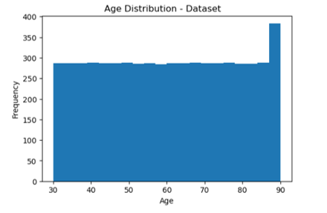
Figure 4.1: Age Distribution of Patients in Dataset
The age variable was retained because it is available before diagnosis and has been used as a predictor in previous lung cancer risk prediction models [16], [30].

4.2.2 Target Class Distribution
The distribution of the target variable was analyzed before model development to determine the proportion of positive and negative observations.
The results showed that:
- No: 368,107 records (79.97%)
- Yes: 92,185 records (20.03%)
Therefore, the dataset contains a moderately imbalanced target distribution.
Previous lung cancer machine learning studies have identified class imbalance as an important consideration during model development. For example, the meta-ensemble study used SMOTE because its dataset contained a highly imbalanced distribution, while other studies also applied balancing techniques before model training [30], [9], [8].
In the present study, no oversampling or undersampling technique was applied during preprocessing. Instead, the original class distribution was retained and stratified train-test splitting was used so that the proportions of the two classes were maintained in the training and testing sets. Similar stratified splitting approaches have been used in lung cancer machine learning studies [9], [10], [7].
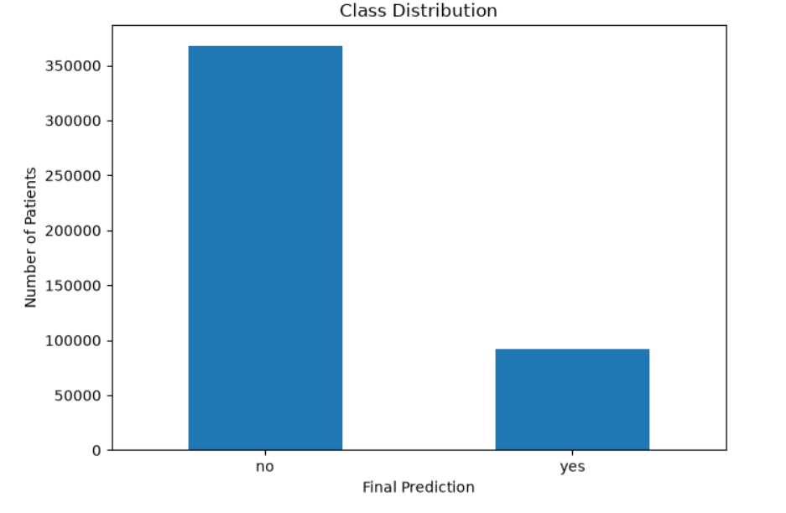
Figure 4.2: Class Distribution Analysis for the Dataset

4.2.3 Correlation Analysis
Correlation analysis was performed to examine relationships among the selected prediction features and the target variable. Previous lung cancer machine learning studies have used correlation analysis and heatmaps to investigate relationships between patient characteristics and lung cancer-related outcomes [7], [32].
A correlation heatmap was generated using the 11 retained prediction features and the target variable.
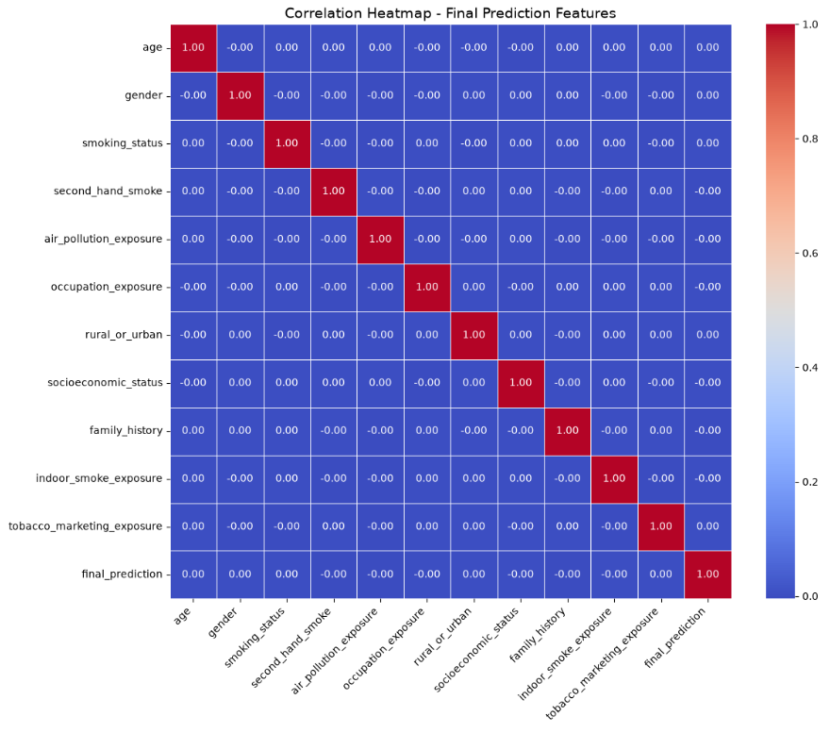
Figure 4.3: Correlation Heatmap of Final Prediction Features
The heatmap was used as a supporting exploratory analysis rather than as the only criterion for feature selection. This is consistent with previous lung cancer studies in which correlation and feature-importance analysis were combined with other model-development and feature-selection procedures [7], [32].

4.2.4 Mutual Information Analysis
Mutual Information (MI) analysis was performed to measure the amount of information provided by each feature about the target variable. MI was used as a supporting feature-selection method, rather than as the only method for selecting the final features.
The MI analysis produced the following results:
Rank | Feature | MI Score
1 | rural_or_urban | 0.066621
2 | insurance_coverage | 0.066544
3 | screening_availability | 0.061672
4 | gender | 0.051493
5 | socioeconomic_status | 0.036306
6 | air_pollution_exposure | 0.031474
7 | smoking_status | 0.028413
8 | healthcare_access | 0.017986
9 | second_hand_smoke | 0.017830
10 | delay_in_diagnosis | 0.017788
11 | tobacco_marketing_exposure | 0.017478
12 | occupation_exposure | 0.013617
13 | indoor_smoke_exposure | 0.013090
14 | family_history | 0.008591
15 | language_barrier | 0.002147
16 | country | 0.002001
17 | age | 0.000718

The MI results were interpreted together with the clinical relevance of the variables, findings from previous lung cancer studies, EDA results, and the suitability of each variable for early risk prediction. This combined approach is consistent with previous studies that examined feature importance and used multiple criteria when developing lung cancer prediction models [10], [16], [29].

Data pre-processing

The preprocessing stage prepared the dataset for machine learning by examining data quality, transforming categorical variables into numerical representations, analyzing potential outliers, selecting suitable prediction features, and preparing the data for model training.

Previous lung cancer machine learning studies have applied similar procedures, including categorical encoding, normalization, feature selection, dataset splitting, and model evaluation [7], [9], [10], [32].

The preprocessing procedures used in this study are described below.

4.3.1. Data Transformation
The dataset contains both numerical and categorical variables. Categorical variables were converted into numerical representations before machine learning model development because the reviewed lung cancer prediction studies also transformed categorical variables into numerical formats before model training [9], [10], [32].
In this study, the selected categorical variables were encoded into numerical values while age was retained as a numerical variable.
The 11 final prediction features after encoding were: Age ,Gender, , Smoking Status ,Second-Hand Smoke , Air Pollution Exposure , Occupation Exposure , Rural or Urban , Socioeconomic Status , Family History , Indoor Smoke Exposure , Tobacco Marketing Exposure .
. 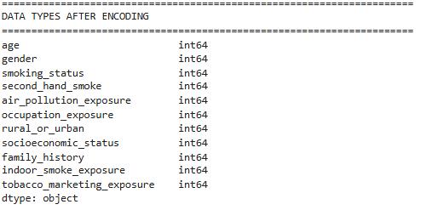
Figure 4.3.1: Encoding
The encoding step allowed the selected categorical variables to be processed by the machine learning algorithms used in the subsequent stages. Similar categorical encoding procedures were reported in previous lung cancer prediction studies [9], [10], [32].
Feature scaling was applied to prepare numerical variables for machine learning algorithms. Previous lung cancer risk prediction research used normalization procedures, including Z-score normalization, before model development [10].
In this study, scaling was applied to the numerical input data to place numerical variables on a comparable scale before model training. This step was included as part of the preparation of the final input data for the machine learning models.

4.3.2. Data Cleaning
Data cleaning was performed before model development to examine whether the dataset contained duplicated observations, missing values, hidden missing values, inconsistent categorical values, or abnormal numerical values. Similar data-cleaning and preprocessing procedures have been applied in previous lung cancer machine learning studies [7], [9], [10], [32].
Duplicate records were specifically checked because duplicated observations can affect the representation of the dataset and may influence model development.
In this study, no exact duplicate rows were detected.
Since no duplicate records were found, no observations were removed. Therefore, all 460,292 original observations were retained.
This decision is also consistent with the principle demonstrated in previous lung cancer research that duplicate records should be inspected before analysis. For example, the early diagnosis study removed duplicate observations before model development when duplicates were actually present [9], while the performance-comparison study also reported removing duplicate records from its dataset [7].
In contrast, because no duplicates were detected in the current dataset, removing records would not have been justified.
Missing-value analysis was performed to determine whether incomplete observations were present in the dataset.
The analysis confirmed the dataset was complete, with no direct or hidden missing values and no unidentified labels, Therefore, no imputation method was required.
Previous lung cancer risk prediction research has used missing-value handling techniques when missing information was present. For example, the study by [10] used MissForest to handle missing values before model development. Since the current dataset contained no missing values, applying an imputation technique was unnecessary.
Categorical variables were inspected to identify inconsistent representations such as unnecessary spaces or differences in text formatting.
The categorical values were standardized before encoding to ensure that equivalent categories were represented consistently.
For example, the rural_or_urban variable was checked before encoding and contained only:
- urban
- rural
The resulting encoded variable contained numerical representations of these two categories.
This procedure was performed before encoding so that different textual representations would not be treated as separate categories during machine learning preprocessing. Categorical encoding and preprocessing of categorical variables have also been applied in previous lung cancer prediction studies [9], [10], [32].
Outlier detection was performed for the numerical age variable using the Interquartile Range (IQR) method.
The analysis identified no age outliers within the defined IQR limits. Therefore, no observations were removed based on age.
The age range of the dataset was 30–90 years, and these observations were retained for subsequent analysis.
This decision avoids removing valid observations simply because they occur toward the higher or lower end of the observed age range. Age has also been used as an input variable in lung cancer risk prediction studies [16], [30], [9].

4.3.3. Data Reduction
Feature selection was performed to identify a suitable set of variables for the intended early lung cancer risk prediction task.
Previous studies have demonstrated the use of feature-importance analysis to identify influential variables for lung cancer prediction. The gradient-boosting risk estimation study used SHAP values to identify important risk factors and reduce the number of questions required by the final prediction tool [16]. Similarly, explainable machine learning studies have used SHAP and other XAI methods to investigate which variables contribute to lung cancer risk predictions [28], [29].
In this study, feature selection was not based solely on a single statistical measure; rather, the final selection was guided by mutual information results, correlation and exploratory data analysis (EDA) findings, evidence from published lung cancer studies, clinical relevance, suitability for early risk prediction, and feedback obtained through the survey.
This combined approach was used because previous lung cancer prediction research has considered multiple patient characteristics and feature-importance methods rather than relying on a single variable-selection criterion [10], [16], [29].

4.3.3.1 Selected Features
Based on the above criteria, 11 features were retained:
Feature | Category | Reason for Selection
Age | Demographic | Used as a lung cancer risk factor in previous prediction studies and available before diagnosis [16], [30]
Gender | Demographic | Included as a patient characteristic in previous lung cancer prediction studies [9], [30], [10]
Smoking Status | Behavioral | Smoking is consistently identified as a major lung cancer risk factor [34], [10], [30]
Second-Hand Smoke | Environmental | Represents passive tobacco exposure and has been included in previous lung cancer risk prediction research [10]
Air Pollution Exposure | Environmental | Represents environmental exposure relevant to lung cancer risk [34]
Occupation Exposure | Occupational | Captures occupational exposure to potentially harmful substances such as asbestos, diesel, coal dust and heavy metals [10], [34]
Rural or Urban | Geographic | Rural and urban populations show differences in smoking, environmental exposure, socioeconomic conditions and lung cancer outcomes [34]
Socioeconomic Status | Socioeconomic | Socioeconomic deprivation has been associated with differences in lung cancer prevalence and mortality [34]
Family History | Genetic/Family | Family history of lung cancer was included among important risk factors in previous prediction studies [16], [10]
Indoor Smoke Exposure | Environmental | Represents an additional environmental exposure relevant to the early-risk assessment framework
Tobacco Marketing Exposure | Social/Behavioral | Represents a tobacco-related social exposure that complements direct smoking-status information

4.3.3.2 Excluded Features
Several variables were excluded because they were not suitable for the intended early risk prediction stage.
Variables related to diagnosis, cancer classification, treatment, mortality, survival, or other information that becomes available after diagnosis were not considered appropriate predictors for an early-risk model.
This decision follows the principle demonstrated in lung cancer risk prediction studies that prediction tools should focus on information available when the risk assessment is performed. For example, the gradient-boosting study developed a short questionnaire using risk factors available for estimating future lung cancer risk [16].
Therefore, the final model focuses on variables that can reasonably be obtained before or during an early risk assessment, rather than variables describing an already diagnosed cancer.

4.3.3.3 Feature-Specific Supporting Evidence
The selected features were further reviewed against the literature.
Age and gender are demographic variables that were included in previous lung cancer prediction studies. Age was specifically included among the important risk factors in the gradient-boosting lung cancer risk estimation study, while age and gender were also included in other comparative lung cancer prediction studies [16], [30], [9].
Smoking status has the strongest direct support among the selected features. The reviewed literature identifies smoking as a major lung cancer risk factor, and the rural–urban review also describes smoking as the most important risk factor for lung cancer [34]. Smoking-related variables were also included in several machine learning lung cancer prediction studies [10], [30].
Second-hand smoke was retained because it represents tobacco exposure that may occur without direct smoking. The Improving Lung Cancer Risk Prediction study included living with smokers among important risk factors, providing support for considering passive tobacco exposure in lung cancer risk prediction [10].
Air pollution exposure was retained to represent an environmental component of lung cancer risk. The rural–urban review discusses environmental exposures and carcinogenic pollutants as factors relevant to lung cancer disparities [34].In addition, air pollution exposure obtained an MI score of 0.031474 and a Chi-square p-value of 0.028773 in the present dataset, providing additional dataset-level support for retaining the variable.
Occupation exposure was retained because occupational environments may expose individuals to harmful substances. The Improving Lung Cancer Risk Prediction study included occupational exposure to asbestos, diesel, coal dust, and heavy metals among its risk-related variables [10]. The rural–urban review also discusses occupational exposure to carcinogens among rural populations [34].
Rural or urban status was retained because the reviewed literature identified substantial differences between rural and urban populations in lung cancer incidence, mortality, smoking exposure, environmental exposure, socioeconomic conditions, and access to screening and treatment [34].
The variable also produced the highest MI score among the 17 evaluated features (0.066621) in the present dataset.
Socioeconomic status was retained because socioeconomic deprivation has been associated with higher lung cancer prevalence and mortality and can be related to differences in healthcare and treatment opportunities [34].
The variable also produced an MI score of 0.036306, providing additional dataset-level evidence for its inclusion.
Family history was retained because familial history of lung cancer was included among the important risk factors in the gradient-boosting risk prediction study and was also identified as an important factor in the comparative machine learning risk prediction study [16], [10].
Indoor smoke exposure was retained as an environmental exposure variable because it represents exposure occurring within the home environment and complements the other environmental and tobacco-related variables in the early-risk prediction framework.
The feature was not selected solely because of its MI score. Instead, its inclusion was based on the combined selection criteria used in this study.
Tobacco marketing exposure was retained as a social and behavioral tobacco-related variable. It was considered complementary to smoking status because it represents exposure to tobacco-promoting influences rather than direct tobacco consumption.
The feature was therefore not treated as equivalent to smoking status or as a direct biological cause of lung cancer. Its inclusion was based on the combined feature-selection framework and its availability as an early exposure-related variable.

4.3.4 Mutual Information and Statistical Analysis
Mutual Information was used as a supporting method for evaluating the relationship between the prediction features and the target variable.
The MI results were not used as the sole basis for feature selection. This decision was important because some clinically relevant variables can have relatively low statistical scores in a particular dataset while still being meaningful for risk prediction.
Previous lung cancer studies have similarly used feature-importance techniques to identify relevant variables. For example, SHAP was used in lung cancer risk prediction and screening studies to investigate the contribution of individual variables to model predictions [16], [29].
Therefore, the final feature set was determined by combining statistical evidence, literature evidence, EDA findings, clinical relevance, survey feedback, and early-prediction suitability.

4.3.5 Train-Test Splitting
After preprocessing and feature selection, the dataset was divided into training and testing subsets.
An 80% training and 20% testing split, and a 70% training and 30% testing split, were used. This approach has also been applied in previous lung cancer machine learning studies, including studies comparing Random Forest, SVM, and Decision Tree models [9] and studies evaluating multiple machine learning algorithms for lung cancer prediction [7].
Stratification was applied during the split to preserve the original proportion of positive and negative target classes in both subsets. This was particularly important because the present dataset contains approximately 80% negative observations and 20% positive observations.
The use of stratification is consistent with previous lung cancer prediction studies that maintained similar class proportions during training and testing [9], [10].
A fixed random state was also used to ensure that the data split could be reproduced consistently during the experiments.

4.5 Conclusion
This chapter presented the preprocessing and exploratory data analysis performed on the Lung Cancer Risk & Prediction Dataset before machine learning model development.
The preprocessing process included data inspection, duplicate detection, missing-value analysis, categorical consistency checking, categorical encoding, age outlier analysis, exploratory data analysis, correlation analysis, mutual information analysis, feature selection, feature scaling, and stratified train-test splitting.
No duplicate rows or unknown labels were detected, and the final selected prediction features contained no missing values.
Feature selection resulted in 11 final prediction features: age, gender, smoking status, second-hand smoke, air pollution exposure, occupation exposure, rural or urban status, socioeconomic status, family history, indoor smoke exposure, and tobacco marketing exposure. These features were selected by considering their relevance to early lung cancer risk prediction together with the results of the exploratory and feature-selection analyses.
Finally, the dataset was prepared for machine learning through categorical encoding, feature scaling, and an 80/20 stratified train-test split and a 70/30 stratified train-test split. Overall, the preprocessing stage provided a clean and consistent dataset suitable for the development and evaluation of the machine learning models presented in the following chapters.

CHAPTER 5: MODEL DESCRIPTION

Overview of the Selected Model / Algorithm
This project proposes a hybrid ensemble ML framework for lung cancer risk prediction using structured healthcare datasets. The framework combines three ML classifiers, namely SVM, RF, and XGBoost, because these models demonstrated strong performance in previous lung cancer prediction and healthcare classification studies [26], [28], [29], [30].
SVM is a supervised ML algorithm that works by finding the optimal boundary that separates classes with the maximum possible margin. It is effective in handling nonlinear relationships between features and class labels, especially in healthcare datasets containing multiple risk-related variables [28].
RF is an ensemble learning algorithm that combines multiple decision trees to improve prediction stability and reduce overfitting. Instead of depending on a single tree, the final prediction is generated based on the combined outputs of several trees, which improves robustness and classification performance [30].
XGBoost is a boosting-based ML algorithm that improves prediction performance by sequentially correcting errors generated by previous trees. It is widely used in healthcare prediction tasks because of its efficiency, scalability, and strong performance in structured datasets [16], [29].
The proposed framework mainly relies on a stacking ensemble approach. In the first stage, SVM, RF, and XGBoost are trained independently as base classifiers using cross-validation and GridSearchCV for hyperparameter optimization. Each model generates prediction probabilities for lung cancer risk. In the second stage, Logistic Regression (LR) is used as the meta-learner to combine the probability outputs generated by the base classifiers and produce the final prediction. LR was selected because it is interpretable, computationally efficient, and suitable for combining probability-based outputs from multiple models [26], [27], [28].
In addition to the stacking ensemble, a Soft Voting ensemble model will also be implemented as a comparative baseline model. In the soft voting approach, the prediction probabilities generated by SVM, RF, and XGBoost are averaged before determining the final class label. The performances of both ensemble approaches will then be compared to identifying the most accurate and reliable prediction framework.
The integration of PSI and DRZ serves as a critical reliability layer for the stacking ensemble. While the meta-learner provides a final prediction, the PSI adds a layer of evidence-based reasoning by identifying historical cases with similar clinical and lifestyle profiles using Mahalanobis Distance. This is followed by the DRZ, which categorize the model's output into high, medium, or low confidence zones. By doing so, the framework does not just provide a binary “cancer” or “no cancer” result but also indicates the level of certainty behind that prediction, which is essential for safe clinical decision support.
SHAP explainability is integrated to explain feature contributions and improve model transparency [26], [27], [25]. In addition, counterfactual explanation is used to identify the minimum feature changes required to reduce lung cancer risk and generate actionable prevention recommendations for patients.

Model Architecture / Structure
The proposed framework is designed as a multi-stage hybrid ensemble architecture for lung cancer risk prediction. The framework combines multiple ML models, ensemble learning techniques, reliability-aware mechanisms, and explainability components within a single prediction system.
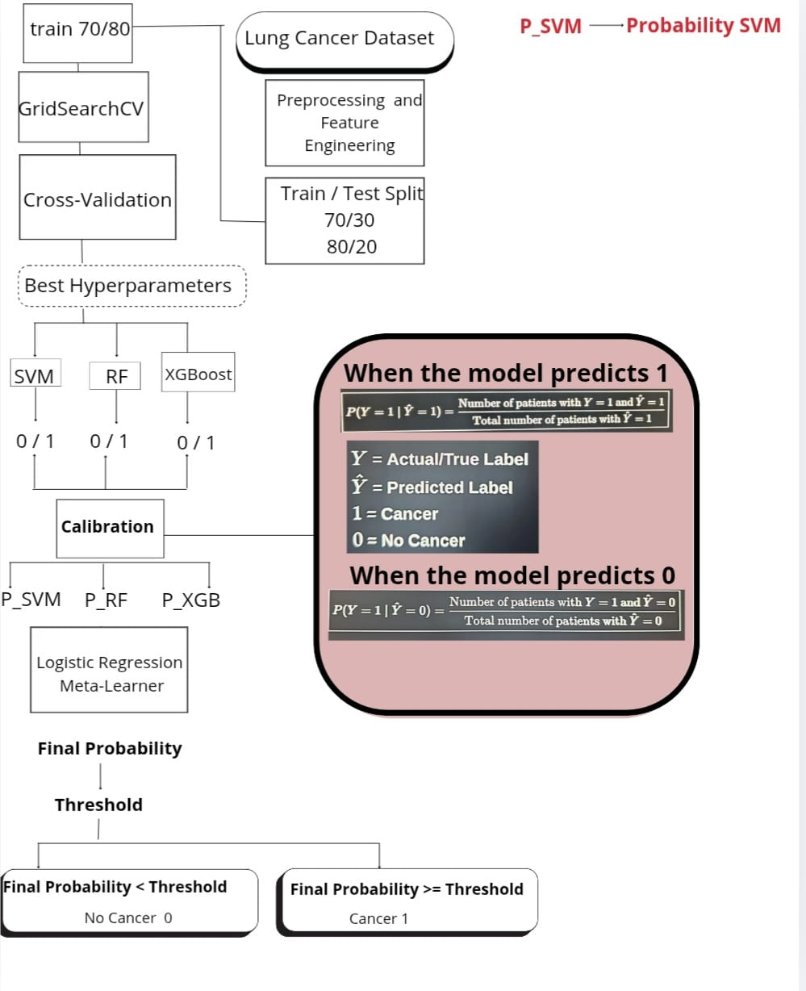
Figure 5.1 illustrates the overall architecture of the proposed hybrid ensemble lung cancer prediction framework.
In the first stage, three base classifiers are trained independently, namely SVM, RF, and XGBoost. SVM uses the Radial Basis Function (RBF) kernel to handle nonlinear relationships between features and class labels in healthcare datasets [28]. The main hyperparameters tuned for SVM include C, which controls the trade-off between margin size and classification accuracy, gamma, which controls the influence of training samples on the decision boundary, and kernel type.
RF is implemented using multiple decision trees to improve robustness and reduce overfitting [30]. Important hyperparameters include n_estimators, which determines the number of trees, max_depth, which controls the depth of each tree, and min_samples_split and min_samples_leaf, which help improve model generalization.
XGBoost is implemented as a boosting classifier that sequentially corrects prediction errors generated by previous trees [16], [29]. Important hyperparameters include learning_rate, max_depth, n_estimators, and subsample. The learning_rate controls the speed of model updates during training, while subsample helps reduce overfitting by training on random subsets of the data.
GridSearchCV with cross-validation will be used to optimize the hyperparameters of all base classifiers using the training data only. Recall-oriented tuning will also be applied to reduce false negative predictions in lung cancer detection tasks.
In the second stage, the prediction probabilities generated by SVM, RF, and XGBoost are combined into meta-features and passed into Logistic Regression, which acts as the meta-learner in the stacking ensemble framework. LR generates the final lung cancer prediction by learning how to combine the outputs produced by the base classifiers [26], [27], [28].

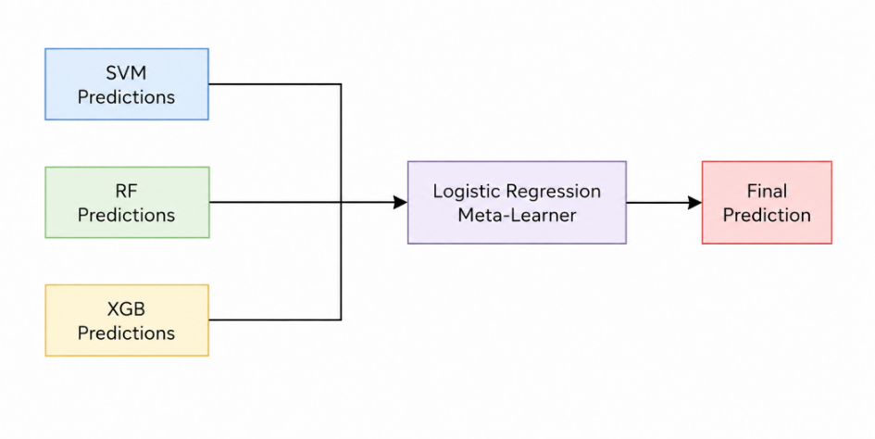
Figure 5.2 presents the stacking ensemble structure used in the proposed framework.
In addition to the stacking ensemble, a Soft Voting ensemble model is also implemented as a comparative baseline model. In the soft voting approach, the prediction probabilities generated by the three base classifiers are averaged before determining the final prediction.
The proposed framework incorporates Patient Similarity Index (PSI) as a reliability-aware similarity analysis mechanism. The purpose of PSI is to identify previously observed patients whose clinical and lifestyle characteristics are similar to those of the current patient. This additional similarity information is used to assess whether the generated prediction is consistent with patterns observed in the training data and to provide additional support for healthcare decision-making.

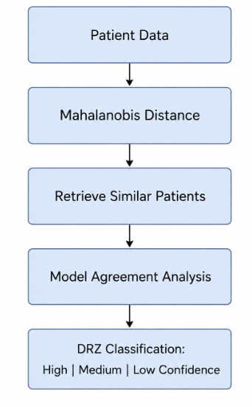
Figure 5.3 shows the PSI and DRZ reliability workflow integrated into the proposed framework.
To measure patient similarity, the framework uses Mahalanobis Distance. This distance measure is selected because it considers the covariance and correlations among multiple features rather than treating each feature independently. This is particularly suitable for structured healthcare datasets, where risk factors such as smoking, age, air pollution exposure, occupational exposure, and other lifestyle-related factors may be interrelated [20], [21].
The pairwise Mahalanobis Distance between the current patient and each reference patient in the training dataset is calculated as follows:


where :
xi represents the feature vector of the current patient.
xj represents the feature vector of a reference patient.
Σ_1 denotes the inverse covariance matrix estimated from the training data. The transpose operation (⋅)T is required for the matrix multiplication.
The covariance matrix is estimated exclusively from the training data to prevent information leakage from the test set. Before calculating the distance, categorical variables are appropriately encoded, and the resulting feature representation is processed consistently for both the current patient and the reference patients.
Lower Mahalanobis Distance values indicate greater similarity between patient profiles, whereas higher values indicate greater dissimilarity. Accordingly, the framework ranks the reference patients according to their Mahalanobis Distance from the current patient and retrieves the -nearest similar patient profiles.
The retrieved similar patients are not used as a replacement for the machine learning prediction. Instead, they provide an additional reliability layer that allows the framework to determine whether the prediction for the current patient is consistent with previously observed patient profiles. For example, if the machine learning models produce a high-risk prediction and the current patient is highly similar to previously observed cases, the prediction is considered more consistent with the reference population. Conversely, if the patient is substantially different from the available reference cases, the prediction may require additional reliability assessment.
In addition to pairwise patient similarity, the Mahalanobis Distance between the current patient and the overall training-data distribution can be calculated separately. This assessment can help identify patients whose feature profiles are substantially different from the population used to train the models. Such cases may represent potential out-of-distribution (OOD) cases and can therefore be considered during the reliability assessment.

Where:

represents the difference between the current patient profile and the average profile of the dataset.
represents the inverse covariance matrix used to normalize the relationships between features.
represents the transpose operation required for matrix multiplication.
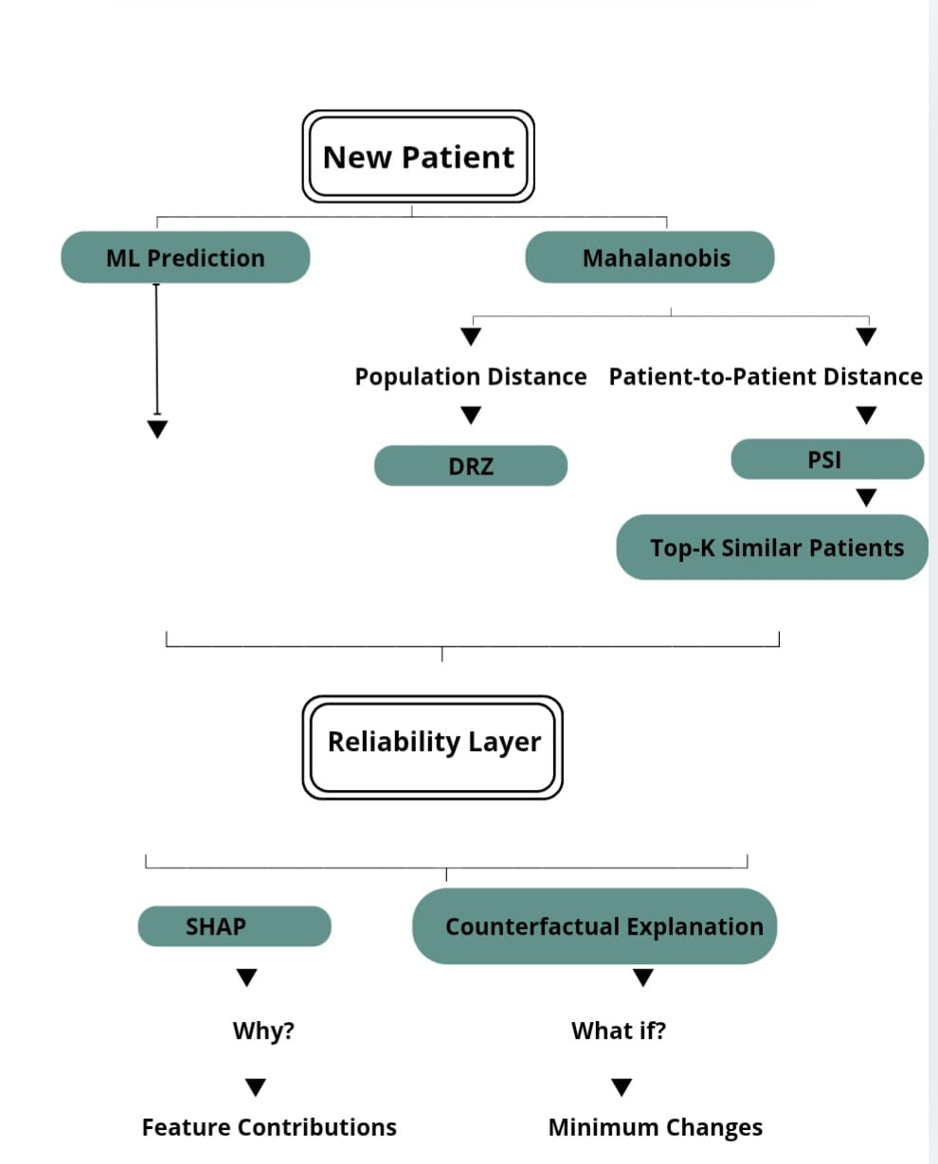

Decision Reliability Zones (DRZ):
Following the generation of the final prediction and the PSI analysis, Decision Reliability Zones (DRZ) are used to classify the prediction according to its estimated reliability level. The DRZ mechanism considers two main factors: the level of agreement among the three base classifiers (SVM, Random Forest, and XGBoost) and the similarity of the current patient to previously observed cases based on Mahalanobis Distance.
A high level of agreement among the base classifiers, combined with high patient similarity, indicates that the prediction is consistent with both the ensemble models and the reference patient population. Such predictions are assigned to the High-Confidence Zone.
Predictions with moderate model agreement or moderately unique patient characteristics are assigned to the Medium-Confidence Zone. These cases indicate a moderate level of reliability and may require additional clinical investigation, diagnostic screening, or further interpretation using SHAP explanations.
Cases in which the base classifiers produce substantially different predictions and the current patient has low similarity to the reference population are assigned to the Low-Confidence Zone. These cases are considered less reliable and may require manual review by healthcare professionals.
Table 5.1 presents the proposed Decision Reliability Zones and their corresponding interpretation.
Reliability Zone | Visual Indicator | Logic / Calculation Criteria | Clinical Interpretation
High-Confidence Zone | Green | Strong agreement among SVM, Random Forest, and XGBoost, together with high patient similarity based on Mahalanobis Distance. | The prediction is highly consistent with previously observed patterns and can provide reliable decision-support information.
Medium-Confidence Zone | Yellow/Orange | Moderate agreement among the ensemble models or moderately unique patient characteristics compared with the reference population. | The prediction has moderate reliability and may require additional investigation or interpretation before further clinical consideration.
Low-Confidence Zone | Red | High disagreement among the base classifiers combined with low patient similarity or highly unique patient characteristics. | The prediction is considered uncertain and should be considered for additional clinical assessment or specialist review.
Table 5.1: Decision Reliability Zones (DRZ) and Their Interpretation
The proposed DRZ mechanism improves the transparency of the prediction framework by distinguishing between predictions that are highly consistent with the reference data and cases that may require additional assessment. Therefore, the system does not provide only a binary prediction of lung cancer risk but also provides information regarding the reliability of the generated prediction [20], [22], [23], [26], [31].

SHAP-Based Explainability:
SHAP (SHapley Additive exPlanations) is integrated into the proposed framework to improve model interpretability and explain the contribution of individual features to the final prediction [25], [26], [27]. SHAP assigns contribution values to the input features, allowing the framework to identify which factors have the greatest influence on the predicted lung cancer risk.
For example, features such as smoking, age, air pollution exposure, occupational exposure, or other available risk factors may contribute positively or negatively to the model's prediction. This information can help healthcare professionals understand the factors that influenced the prediction rather than relying only on the final classification result.
SHAP explanations therefore provide an additional interpretability layer that complements the reliability information provided by PSI and DRZ.

Counterfactual Explanation:
In addition to SHAP, counterfactual explanation is incorporated to provide an alternative perspective on the prediction. While SHAP explains why the model generated a particular prediction, counterfactual analysis investigates what changes in the input features could potentially lead to a different model prediction.
The counterfactual analysis focuses primarily on modifiable risk-related features available in the dataset, such as smoking, and air pollution exposure. The objective is to identify the minimum changes in relevant input features that could result in a lower predicted lung cancer risk according to the model.
These counterfactual results can provide actionable information regarding modifiable factors and may support preventive discussions between healthcare professionals and patients. However, counterfactual explanations represent changes in the model's prediction based on the available data and should not be interpreted as evidence that changing a specific factor will medically prevent lung cancer.

Implementation Plan
The proposed framework will be implemented using Python because it supports machine learning, data preprocessing, model evaluation, and explainability tasks. The main libraries used in this project include Pandas and NumPy for data handling, Scikit-learn for preprocessing, train-test splitting, SVM, Random Forest, Logistic Regression, Soft Voting, GridSearchCV, and evaluation metrics. XGBoost will be used for the boosting classifier, while SHAP will be used for model explainability.
the dataset will be divided into training and testing sets using an 80/20 ratio to evaluate the performance of the proposed framework on unseen data [13]. Additional experiments using a 70/30 split will also be conducted to examine the stability and consistency of the models under different data distributions. These validation strategies help ensure that the developed models do not depend on a single train-test configuration.
To improve reliability and reduce overfitting, k-fold cross-validation will be applied during the training stage [16], [30]. In this approach, the dataset is divided into multiple subsets, where the models are trained on a group of subsets and validated on the remaining subset. This process is repeated several times using different validation folds to produce more stable and generalized results [16], [30].
Furthermore, optimized classification thresholds will be evaluated instead of relying only on the default threshold value of 0.5 in order to improve recall and reduce false negative predictions in lung cancer detection tasks, since healthcare prediction systems often require sensitivity-oriented optimization and reliability-aware decision-making [26], [29], [22], [23].
The implementation will start by loading the raw lung cancer dataset and applying preprocessing steps such as handling missing values, removing duplicates, encoding categorical variables. After preprocessing, the data will be split into training and testing sets using train_test_split.
Next, the three base classifiers, SVM, Random Forest, and XGBoost, will be trained independently. GridSearchCV with cross-validation will be applied to tune the main hyperparameters of each model. The best versions of the base models will then be used in the ensemble stage.
For the stacking ensemble, the prediction probabilities generated by the base classifiers will be combined into meta-features and passed into LR as the meta-learner. A Soft Voting model will also be implemented by averaging the prediction probabilities from SVM, RF, and XGBoost. Both ensemble methods will be tested and compared.
After prediction, PSI will be applied using Mahalanobis Distance to retrieve similar patient cases, while DRZ will classify the prediction into reliability zones. SHAP will then be used to explain the most important factors affecting the prediction, and counterfactual explanation will be applied to suggest possible changes in modifiable risk factors.
Finally, the models will be evaluated using accuracy, precision, recall, F1-score, ROC-AUC, and confusion matrix. The best-performing and most reliable model will be saved for future deployment or integration into a lung cancer prediction support system.

Evaluation Methods
The performance of the proposed lung cancer prediction framework will be evaluated using several classification metrics to measure the accuracy, reliability, and effectiveness of the developed models. Since the project focuses on a healthcare-related classification problem, special attention will be given to reducing false negative predictions during evaluation.
Accuracy will be used to measure the overall percentage of correctly classified cases. Precision will evaluate how many predicted positive lung cancer cases are actually positive, while recall will measure the model’s ability to correctly identify patients with lung cancer. Recall is considered especially important in this project because failing to detect a cancer case may lead to serious healthcare consequences.
The F1-score will also be used because it provides a balance between precision and recall, especially when dealing with imbalanced datasets. In addition, the Receiver Operating Characteristic Area Under the Curve (ROC-AUC) score will be used to evaluate the ability of the models to distinguish between positive and negative classes across different classification thresholds.
Confusion matrices will be used to visualize true positives, true negatives, false positives, and false negatives for each model. The performances of the stacking ensemble and Soft Voting ensemble will then be compared using these evaluation metrics to identify the most accurate and reliable prediction framework.
To further improve reliability evaluation, optimized classification thresholds and DRZ will also be analyzed to measure prediction confidence, uncertainty levels, and false negative reduction in lung cancer prediction tasks [31], [22], [23].

Summary
This chapter presented the proposed hybrid ensemble ML framework for lung cancer risk prediction. The framework combines SVM, RF, and XGBoost as base classifiers within a stacking ensemble architecture, while LR is used as the meta-learner. In addition, a Soft Voting ensemble model is implemented as a comparative baseline model to evaluate the effectiveness of the proposed stacking approach.
The implementation process will be carried out using Python and several ML libraries, including Scikit-learn, XGBoost, Pandas, and NumPy. The datasets will first undergo preprocessing and feature preparation before training the models. Hyperparameter optimization using GridSearchCV, recall-oriented tuning, and optimized classification thresholds will also be applied to improve prediction performance and reduce false negative predictions.
To improve prediction reliability and interpretability, the framework also integrates PSI, DRZ, SHAP explainability, and counterfactual risk explanation. These components are expected to improve confidence estimation, transparency, and healthcare decision support.

CHAPTER 6: CONCLUSION AND FUTURE WORK

Conclusion
This project aims to develop a lung cancer prediction model using SVM, Random Forest, and XGBoost as base classifiers within a stacking ensemble, with Logistic Regression used as the meta-learner rather than as an additional base classifier. A Soft Voting ensemble is also implemented for comparative evaluation alongside the stacking approach, in order to improve prediction performance. The project includes data preprocessing, model training, and performance evaluation to enhance prediction accuracy and reduce missed lung cancer cases. It also focuses on identifying the most significant risk factors associated with lung cancer, such as smoking, age, and air pollution.
In addition, the project incorporates PSI, DRZ, SHAP explanations, and counterfactual analysis to improve the interpretability of the prediction results and make them easier for both doctors and patients to understand.
Overall, the project seeks to support the early detection of lung cancer and contribute to improving healthcare decision-making, in alignment with the goals of digital transformation and healthcare innovation under Oman Vision 2040.

Future Work (Sem 2 work)
The following are identified as future work of this project.
- ML Model Development and Configuration:
Explore and optimize the selected ML algorithms, including Logistic Regression, Random Forest, XGBoost, SVM and Soft Voting for comparative and ensemble learning approaches using Python. This includes understanding their hyperparameters, strengths, limitations, and suitability for lung cancer prediction tasks.
- Evaluating the Models:
Evaluate the performance of all developed models using several classification metrics such as Accuracy, Precision, Recall, F1-score, ROC-AUC, and Confusion Matrix. Special attention will be given to Recall to reduce false negative predictions in lung cancer detection. Compare the performance of our models with the baseline model to choose the best model.
- Integrate Reliability and Explain ability Techniques:
Implement PSI, DRZ, SHAP explain ability, and counterfactual analysis to improve prediction reliability, transparency, and clinical interpretability.
- Improve Generalization and Validation:
Apply threshold optimization techniques to improve model stability, generalization, and performance under different train-test splits and patient profiles
- Web-Based Application:
The project will develop a web-based application that integrates ML prediction models with advanced explain ability techniques.

REFERENCES
- [1] F. Bray, M. Laversanne, H. Sung, J. Ferlay, R. L. Siegel, I. Soerjomataram, and A. Jemal, “Global cancer statistics 2022: GLOBOCAN estimates of incidence and mortality worldwide for 36 cancers in 185 countries,” CA: A Cancer Journal for Clinicians, vol. 74, no. 3, pp. 229–263, 2024.
- [2] Y. Zhang et al., “Global burden of lung cancer attributable to second-hand smoke from 1990 to 2021: a spatiotemporal analysis,” Frontiers in Oncology, vol. 15, 2025, Art. no. 1609230.
- [3] R. L. Siegel, A. N. Giaquinto, and A. Jemal, “Cancer statistics, 2024,” CA: A Cancer Journal for Clinicians, vol. 74, no. 1, pp. 12–49, 2024.
- [4] C. Wang, J. Shao, L. Song, P. Ren, D. Liu, and W. Li, “Persistent increase and improved survival of stage I lung cancer based on a large-scale real-world sample of 26,226 cases,” Chinese Medical Journal, vol. 136, no. 16, pp. 1937–1948, Aug. 2023.
- [5] Y. Sinjanka, V. Kaur, U. I. Musa, and K. Kaur, “ML based early detection of lung cancer: an integrated and in depth analytical framework,” Discover Artificial Intelligence, vol. 4, art. no. 92, Nov. 2024.
- [6] R. Lamba, P. Rani, R. K. Sachdeva, P. Bathla, K. Kumar, V. Mittal, and K. Joshi, “An optimized predictive machine learning model for lung cancer diagnosis,” Biomedical and Pharmacology Journal, vol. 18, March Special Edition, pp. 85–98, Feb. 2025.
- [7] S. P. Maurya et al., “Performance of Machine Learning Algorithms for Lung Cancer Prediction,” Scientific Reports, 2024.
- [8] E. Dritsas and M. Trigka, “Lung Cancer Risk Prediction with Machine Learning Models,” Big Data and Cognitive Computing, 2022.
- [9] Q. Lan et al., “Early Diagnosis and Classification of Lung Cancer Driven by Multi-Feature Data,” 2024.
- [10] H. Tu et al., “Improving Lung Cancer Risk Prediction Using Machine Learning,” Cancers, 2025.
- [11] A. N. Burnett-Hartman et al., “Using Electronic Health Record Data to Calculate Lung Cancer Risk and Inform Lung Cancer Screening,” CHEST Journal, 2023.
- [12] M. C.-H. Yeh, Y.-H. Wang, H.-C. Yang, K.-J. Bai, H.-H. Wang, and Y.-C. J. Li, “Artificial intelligence–based prediction of lung cancer risk using nonimaging electronic medical records: Deep learning approach,” Journal of Medical Internet Research, vol. 23, no. 8, p. e26256, Aug. 2021.
- [13] M. Al Ghafari, B. Al Alawi, I. Aal Jumaa, and S. Al Awaidy, “Oman Vision 2040: A Transformative Blueprint for a Leading Healthcare System with International Standards,” Healthcare, vol. 13, no. 22, p. 2911, Nov. 2025.
- [14] E. Qutieshat, “The healthcare sector in the Sultanate of Oman and the legal control of the utilization of AI systems,” Veredas do Direito, vol. 23, no. 2, Art. no. e234254, Jan. 2026.
- [15] H. Krismanuel, “Exploring genetic susceptibility to air pollution and its implications for disease risk and precision health: A scoping review,” AIMS Public Health, vol. 12, no. 3, pp. 916–951, Sep. 2025.
- [16] P.-L. Benveniste, J. Alberge, L. Xing, and J.-E. Bibault, “Development and external validation of a lung cancer risk estimation tool using gradient-boosting,” arXiv preprint, arXiv:2308.12188, 2023.
- [17] I. Rogers, M. Cooper, A. Memon, L. Forbes, H. van Marwijk, and E. Ford, “The effect of comorbidities on diagnostic interval for lung cancer in England: a cohort study using electronic health record data,” British Journal of Cancer, vol. 131, pp. 1147–1157, 2024.
- [18] N. Innab et al., “AI-Driven Predictive Modeling for Lung Cancer Detection and Management Using Synthetic Data Augmentation and Random Forest Classifier,” International Journal of Computational Intelligence Systems, 2025.
- [19] S. M. AI Okla et al., “The Impact of Air Pollution on Asthma Severity among Residents Living near the Main Industrial Complex in Oman: A Cross-Sectional Study,” International Journal of Environmental Research and Public Health, vol. 21, no. 5, May 2024, Art. no. 553.
- [20] S. Pai and G. D. Bader, “Patient Similarity Networks for Precision Medicine,” Journal of Molecular Biology, vol. 430, no. 18, pp. 2924–2938, 2018.
- [21] F. Wang et al., “Reliability-aware Prediction of Disease Progression Using Patient Similarity,” IEEE, 2020.
- [22] H. Karimi and R. Samavi, “Quantifying Deep Learning Model Uncertainty in Conformal Prediction,” Proceedings of the AAAI Symposium Series, vol. 1, no. 1, pp. 142–148, 2023.
- [23] S. Pal, “Towards Reliable Lung Cancer Prediction: A Hybrid Framework for Noise Reduction and Uncertainty Control,” AAAI Publications, 2025.
- [24] A. Panday, “Lung Cancer Risk and Prediction Dataset,” Kaggle. [Online]. Available: https://www.kaggle.com/datasets/ankushpanday1/lung-cancer-risk-and-prediction-dataset
- [25] M. Tracegod, “Lung Cancer Risk Dataset,” Kaggle. [Online]. Available: https://www.kaggle.com/datasets/mikeytracegod/lung-cancer-risk-dataset
- [26] B. Gebeyehu et al., “Detection of Rare Medical Events in Electronic Health Records Using Machine Learning: Current Practices and Suggestions – A Scoping Review,” PLOS One, 2026.
- [27] E. Koutoulakis, E. Trivizakis, et al., “A Critical Review of Explainable Deep Learning in Lung Cancer Diagnosis,” 2026.
- [28] S. M. Ganie, P. K. D. Pramanik, and Z. Zhao, “Enhanced and Interpretable Prediction of Multiple Cancer Types Using a Stacking Ensemble Approach with SHAP Analysis,” 2025.
- [29] K. Kobylińska, T. Orłowski, M. Adamek, and P. Biecek, “Explainable Machine Learning for Lung Cancer Screening Models,” 2022.
- [30] S. O. Olawale-Shosanya et al., “A Meta-Ensemble Predictive Model for the Risk of Lung Cancer,” 2024.
- [31] M. S. I. Sumon et al., “Integrative Stacking Machine Learning Model for Small Cell Lung Cancer Prediction Using Metabolomics Profiling,” 2024.
- [32] G. H. Sandhya and P. Veeraswamy, “Lung Cancer Prediction Using Machine Learning: A Comparative Analysis Of KNN, SVM, Random Forest,” Vascular & Endovascular Review, vol. 8, no. 5s, pp. 419–427, 2025.
- [33] E. Begoli et al., “Uncertainty-aware Precision Medicine: Beyond Individual Outcome Prediction,” Journal of Biomedical Informatics, 2020.
- [34] Gargapati, A.; Fox, J.; Massarelli, E. Disparities in Lung Cancer Health Outcomes and Access to Lung Cancer Screening Between Rural and Urban Areas in the U.S. Cancers 2026, 18, 864.
APPENDICES
Appendix A: Questionnaire (Done by Medical Staff)
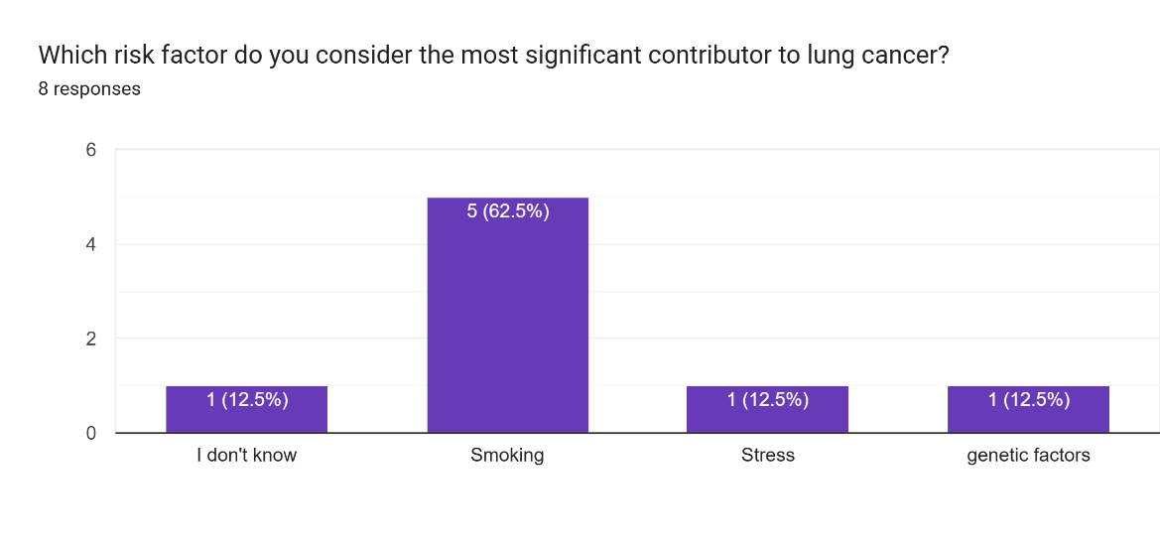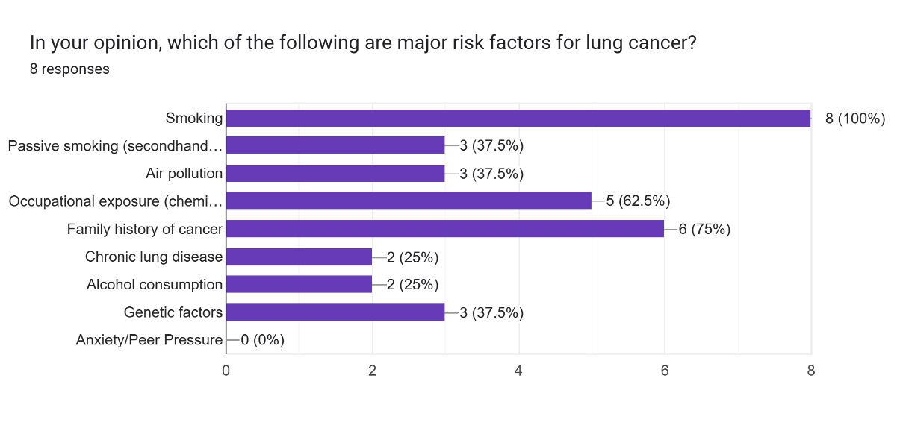
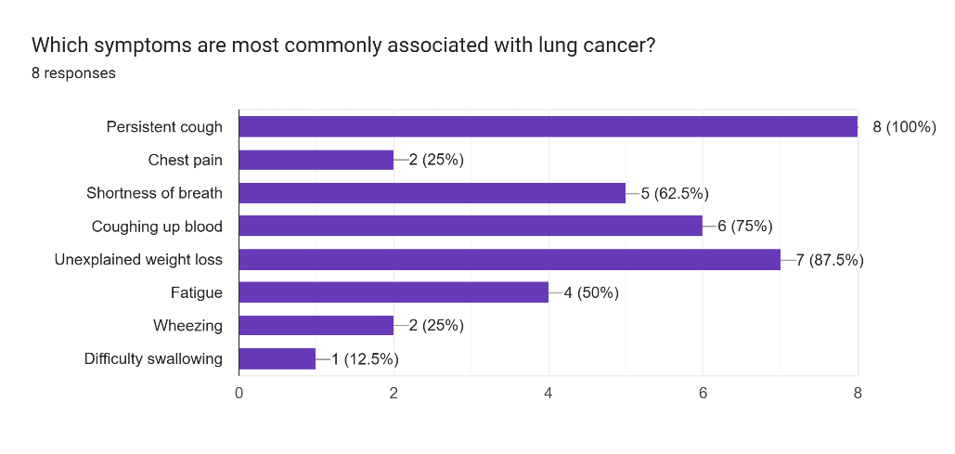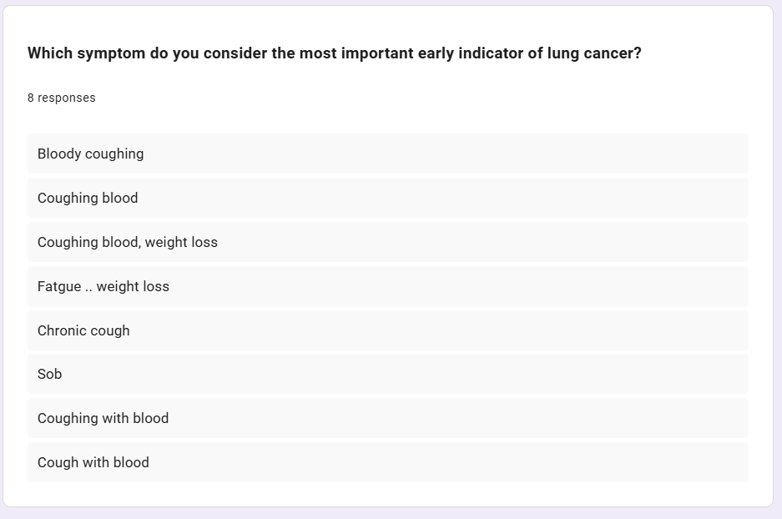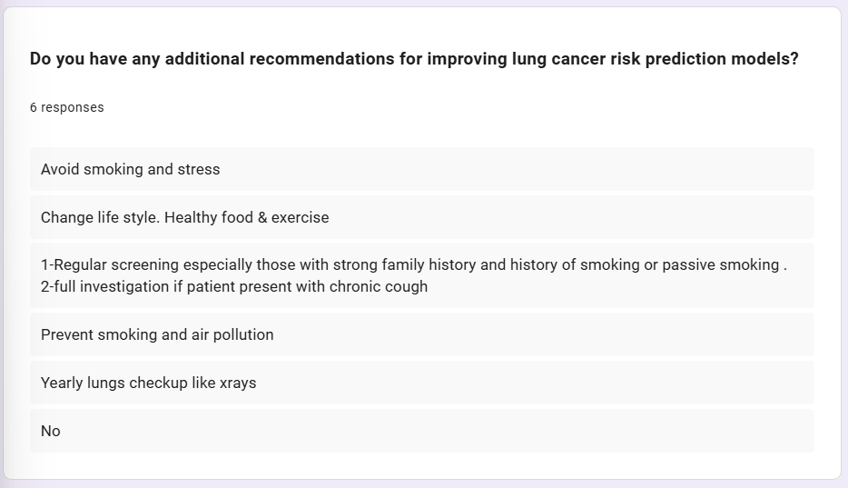

Appendix B: Codes
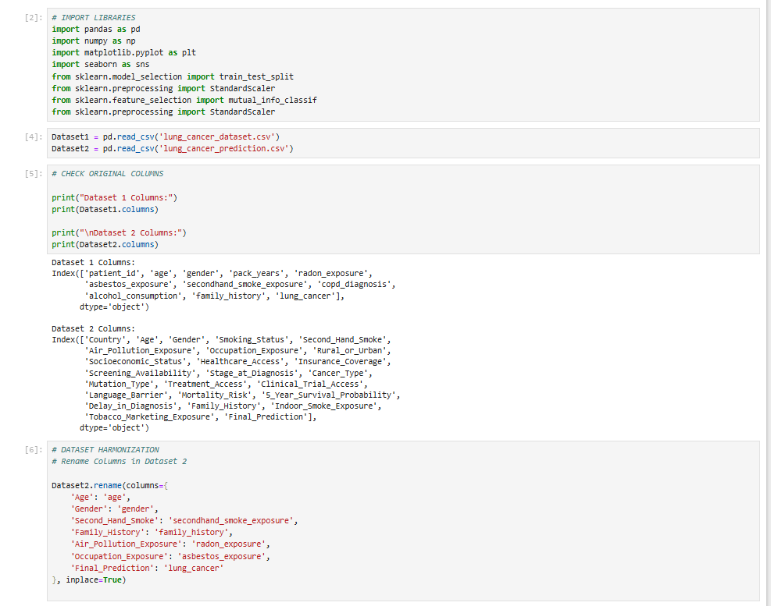
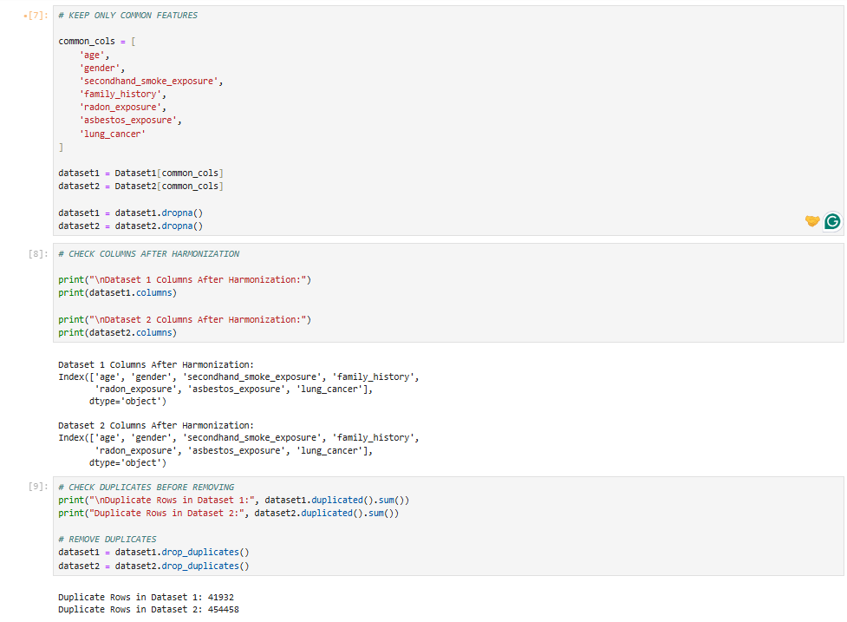
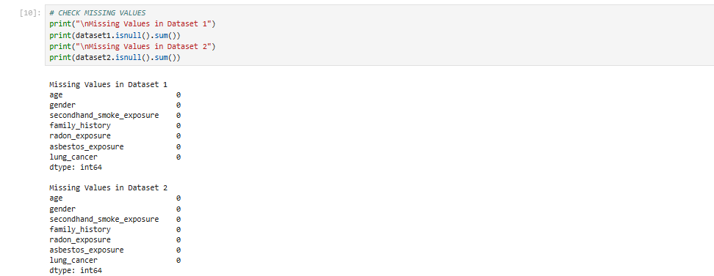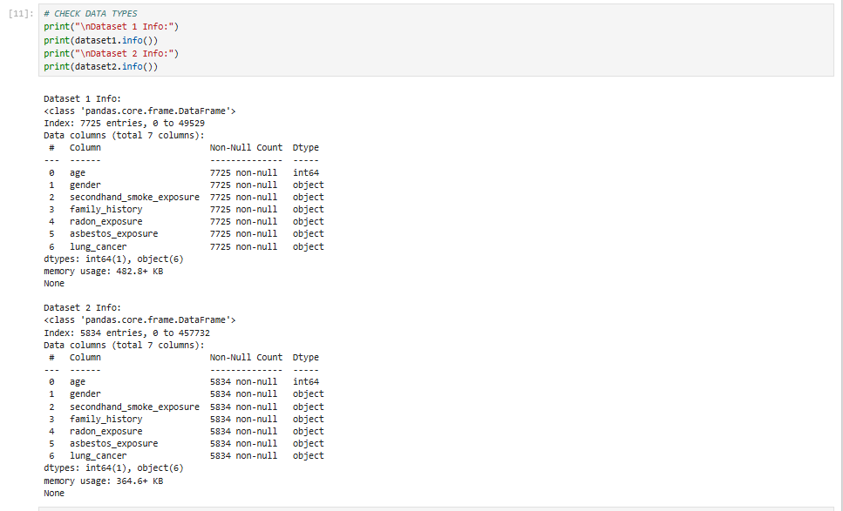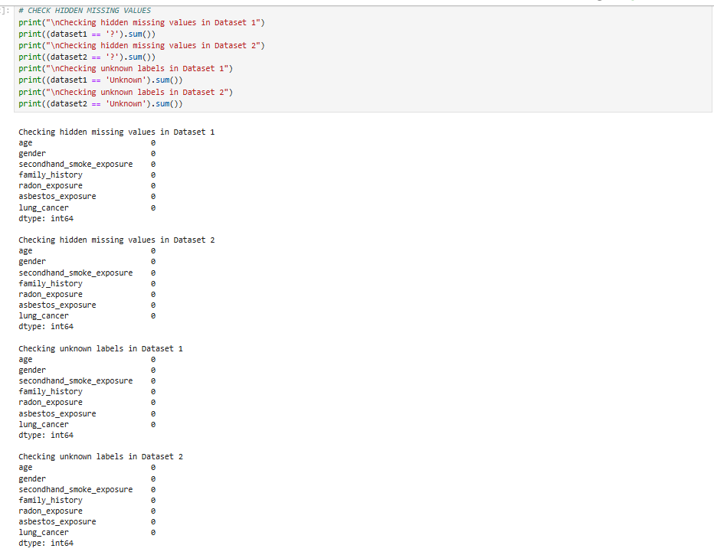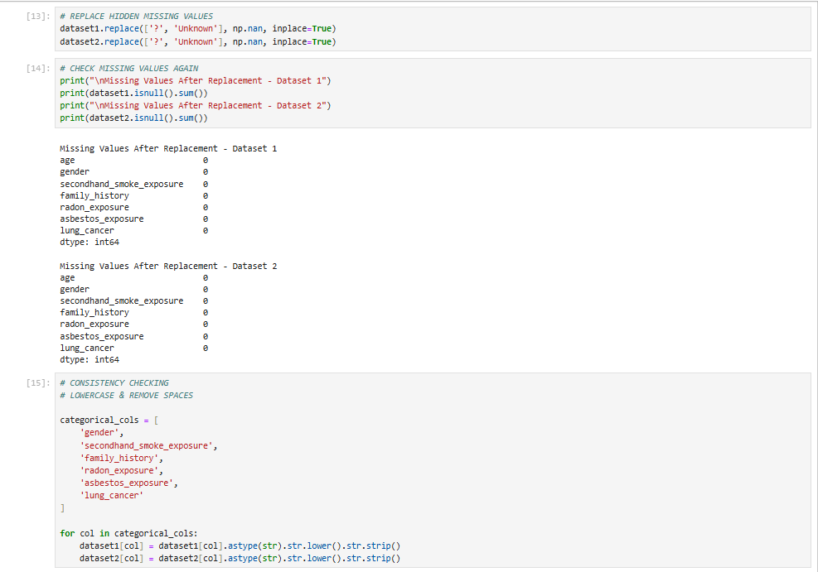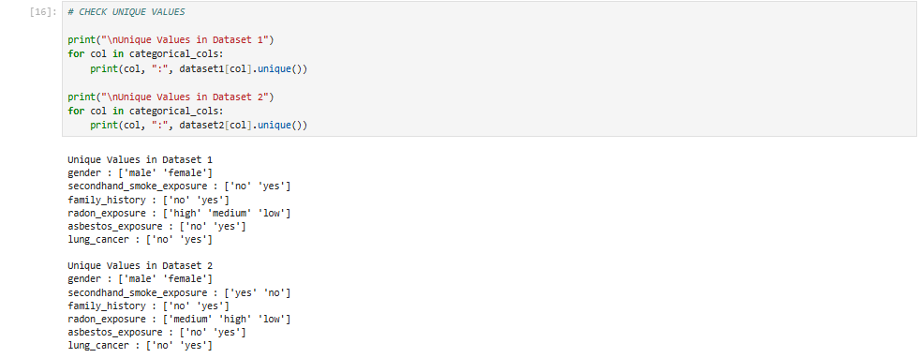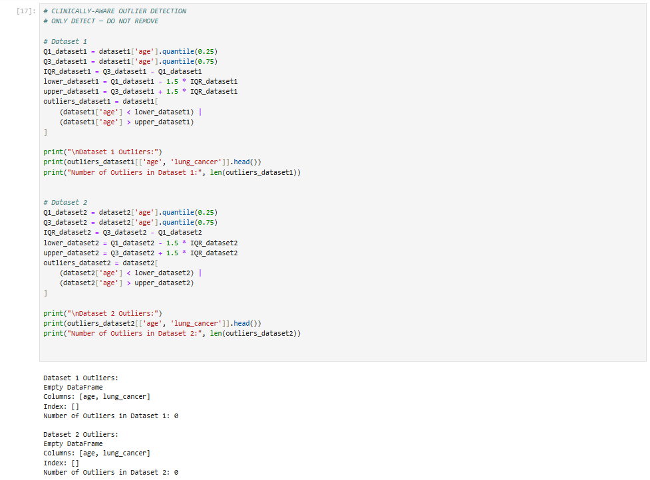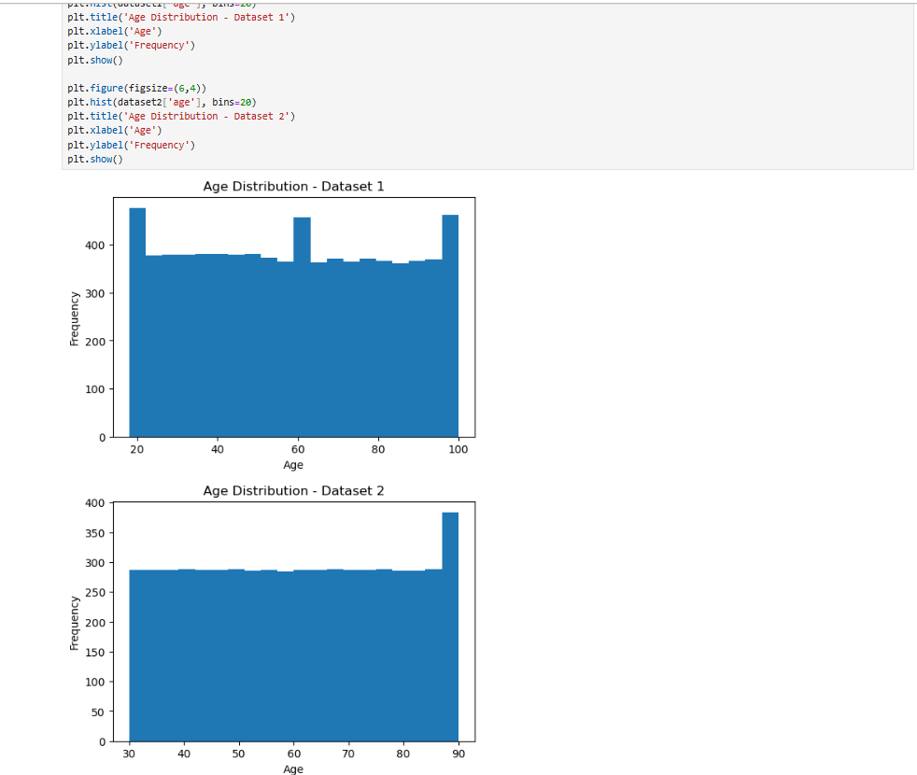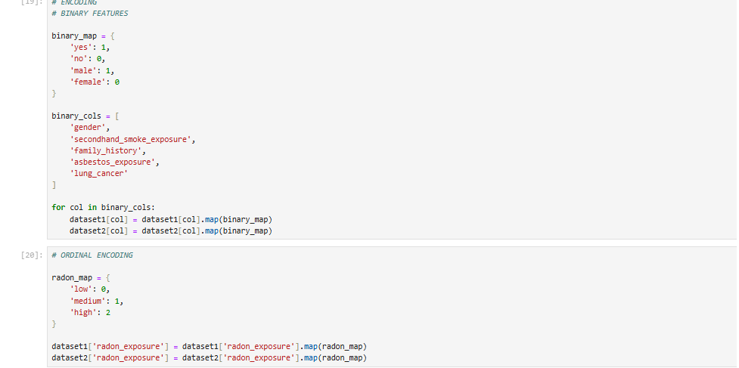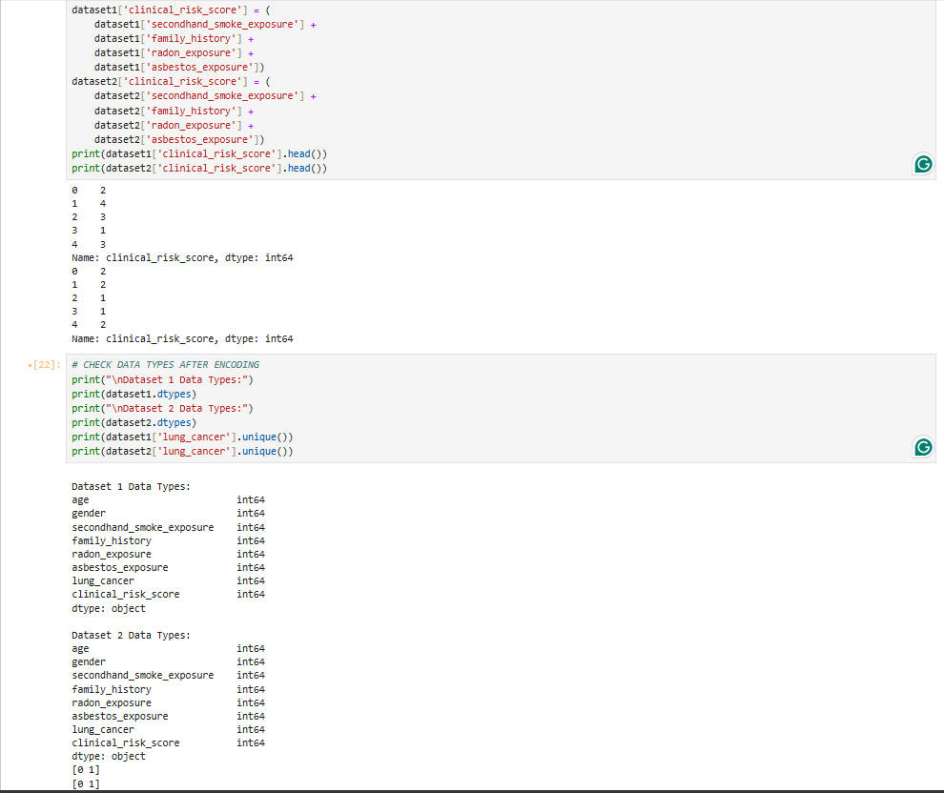
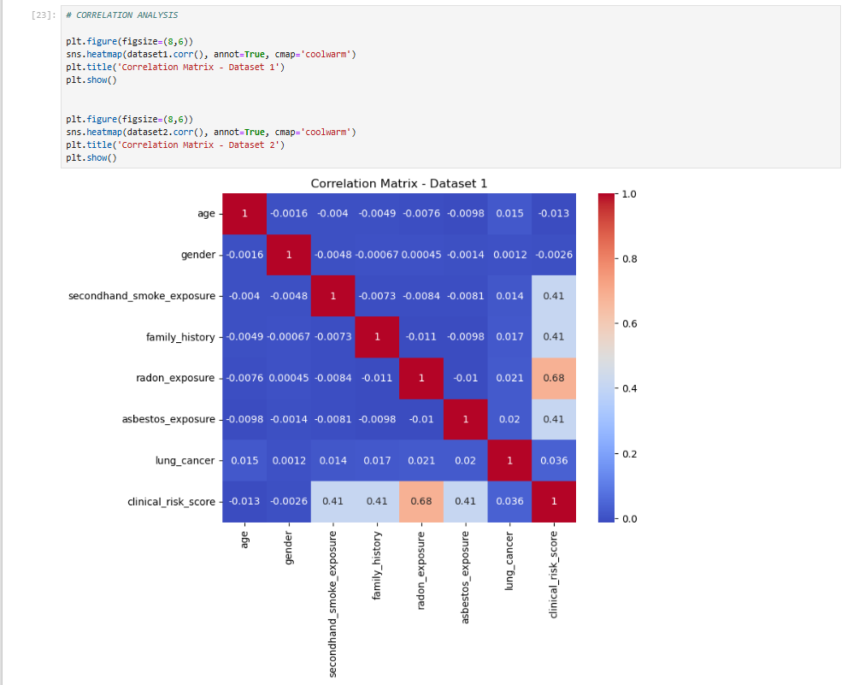
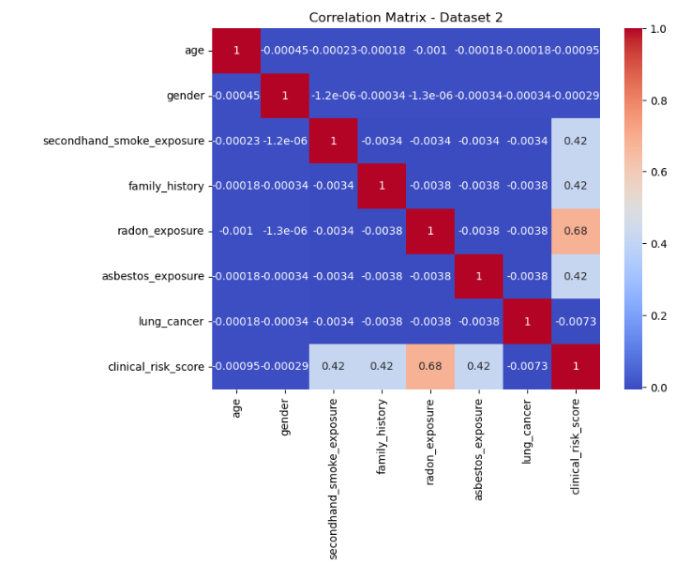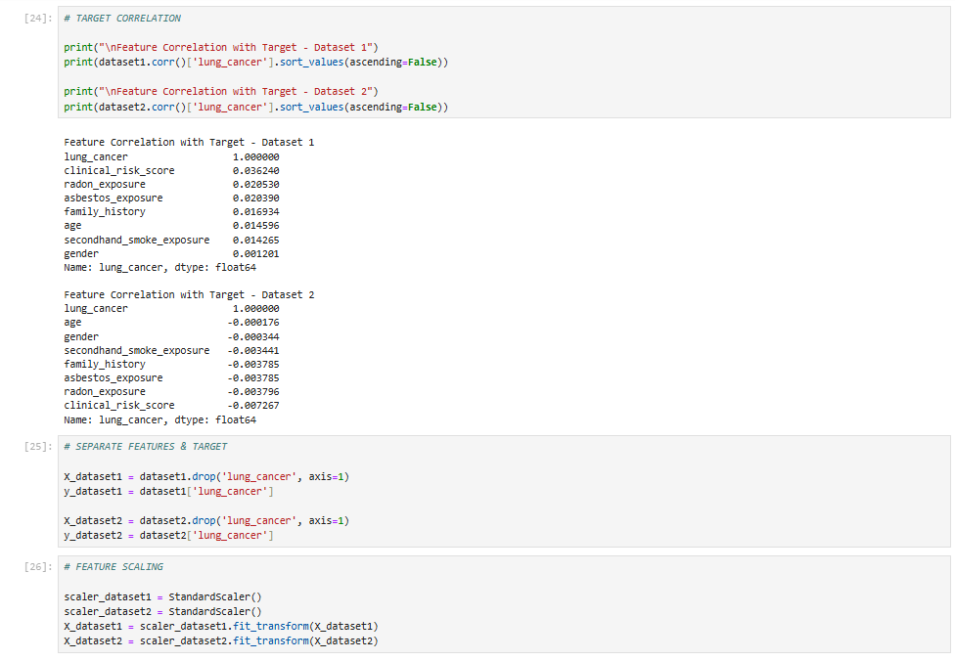
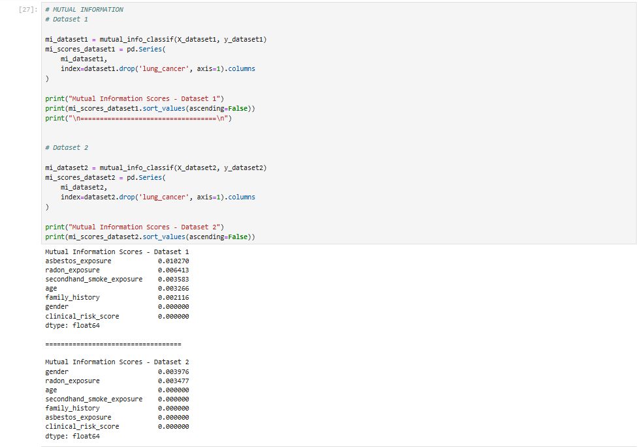
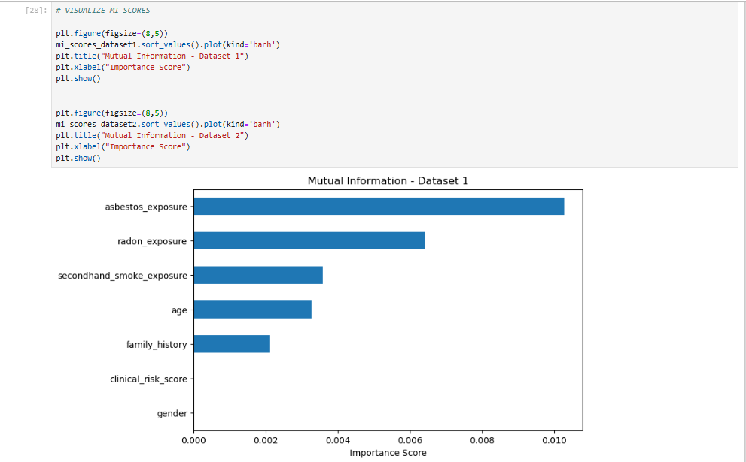
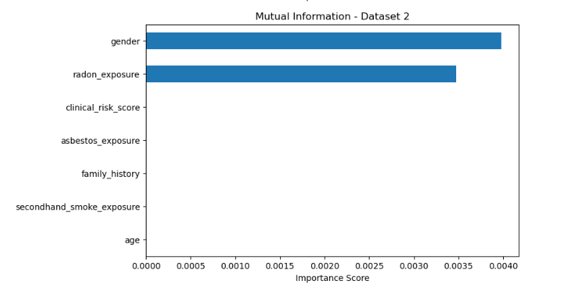
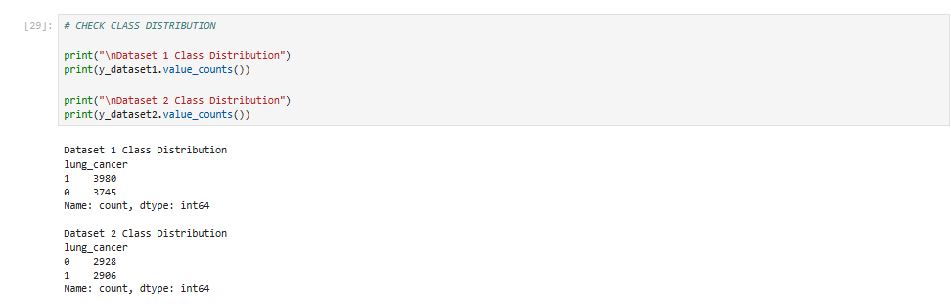
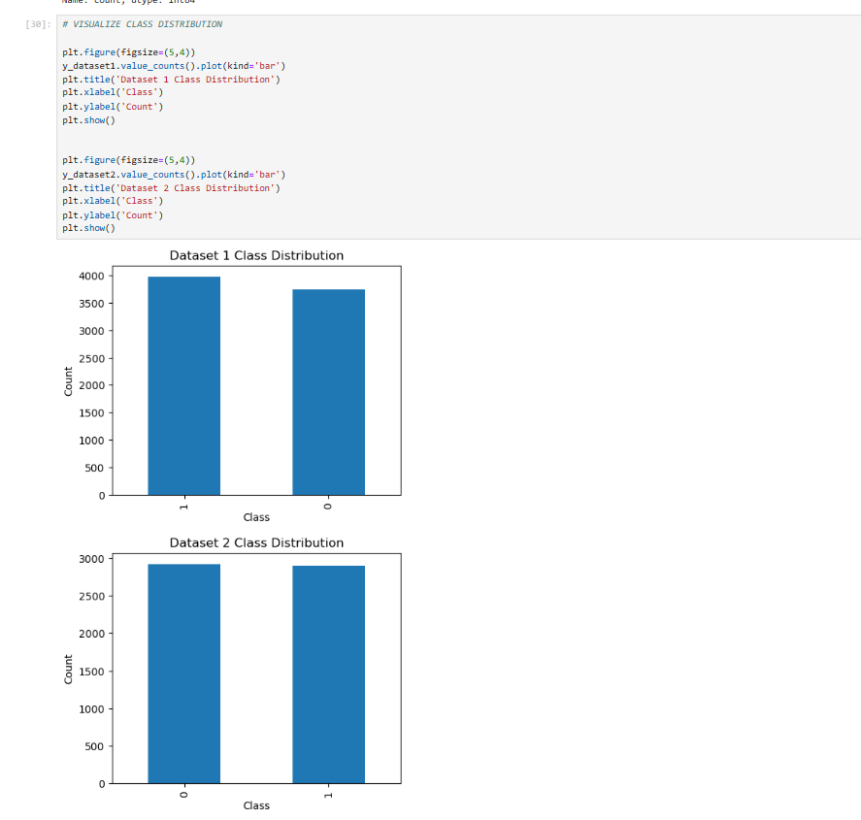
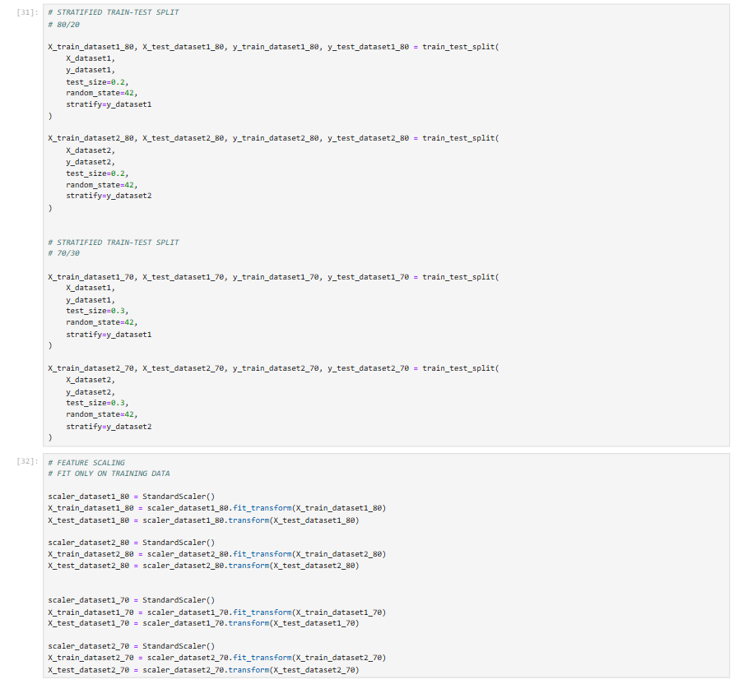
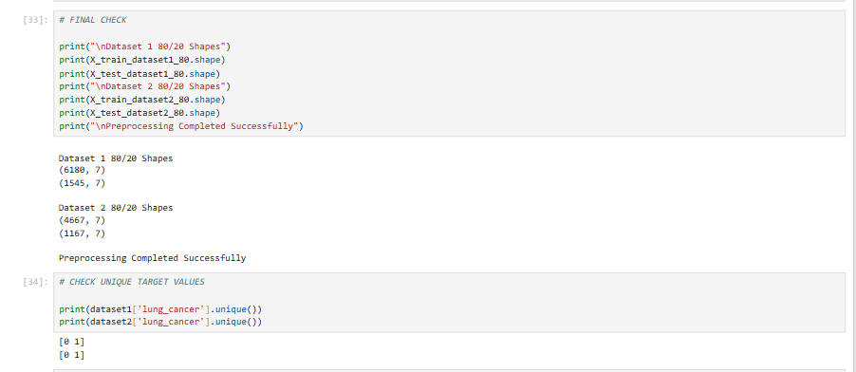

REFERENCES
- [1] F. Bray, M. Laversanne, H. Sung, J. Ferlay, R. L. Siegel, I. Soerjomataram, and A. Jemal, “Global cancer statistics 2022: GLOBOCAN estimates of incidence and mortality worldwide for 36 cancers in 185 countries,” CA: A Cancer Journal for Clinicians, vol. 74, no. 3, pp. 229–263, 2024.
- [2] Y. Zhang et al., “Global burden of lung cancer attributable to second-hand smoke from 1990 to 2021: a spatiotemporal analysis,” Frontiers in Oncology, vol. 15, 2025, Art. no. 1609230.
- [3] R. L. Siegel, A. N. Giaquinto, and A. Jemal, “Cancer statistics, 2024,” CA: A Cancer Journal for Clinicians, vol. 74, no. 1, pp. 12–49, 2024.
- [4] C. Wang, J. Shao, L. Song, P. Ren, D. Liu, and W. Li, “Persistent increase and improved survival of stage I lung cancer based on a large-scale real-world sample of 26,226 cases,” Chinese Medical Journal, vol. 136, no. 16, pp. 1937–1948, Aug. 2023.
- [5] Y. Sinjanka, V. Kaur, U. I. Musa, and K. Kaur, “ML based early detection of lung cancer: an integrated and in depth analytical framework,” Discover Artificial Intelligence, vol. 4, art. no. 92, Nov. 2024.
- [6] R. Lamba, P. Rani, R. K. Sachdeva, P. Bathla, K. Kumar, V. Mittal, and K. Joshi, “An optimized predictive machine learning model for lung cancer diagnosis,” Biomedical and Pharmacology Journal, vol. 18, March Special Edition, pp. 85–98, Feb. 2025.
- [7] S. P. Maurya et al., “Performance of Machine Learning Algorithms for Lung Cancer Prediction,” Scientific Reports, 2024.
- [8] E. Dritsas and M. Trigka, “Lung Cancer Risk Prediction with Machine Learning Models,” Big Data and Cognitive Computing, 2022.
- [9] Q. Lan et al., “Early Diagnosis and Classification of Lung Cancer Driven by Multi-Feature Data,” 2024.
- [10] H. Tu et al., “Improving Lung Cancer Risk Prediction Using Machine Learning,” Cancers, 2025.
- [11] A. N. Burnett-Hartman et al., “Using Electronic Health Record Data to Calculate Lung Cancer Risk and Inform Lung Cancer Screening,” CHEST Journal, 2023.
- [12] M. C.-H. Yeh, Y.-H. Wang, H.-C. Yang, K.-J. Bai, H.-H. Wang, and Y.-C. J. Li, “Artificial intelligence–based prediction of lung cancer risk using nonimaging electronic medical records: Deep learning approach,” Journal of Medical Internet Research, vol. 23, no. 8, p. e26256, Aug. 2021.
- [13] M. Al Ghafari, B. Al Alawi, I. Aal Jumaa, and S. Al Awaidy, “Oman Vision 2040: A Transformative Blueprint for a Leading Healthcare System with International Standards,” Healthcare, vol. 13, no. 22, p. 2911, Nov. 2025.
- [14] E. Qutieshat, “The healthcare sector in the Sultanate of Oman and the legal control of the utilization of AI systems,” Veredas do Direito, vol. 23, no. 2, Art. no. e234254, Jan. 2026.
- [15] H. Krismanuel, “Exploring genetic susceptibility to air pollution and its implications for disease risk and precision health: A scoping review,” AIMS Public Health, vol. 12, no. 3, pp. 916–951, Sep. 2025.
- [16] P.-L. Benveniste, J. Alberge, L. Xing, and J.-E. Bibault, “Development and external validation of a lung cancer risk estimation tool using gradient-boosting,” arXiv preprint, arXiv:2308.12188, 2023.
- [17] I. Rogers, M. Cooper, A. Memon, L. Forbes, H. van Marwijk, and E. Ford, “The effect of comorbidities on diagnostic interval for lung cancer in England: a cohort study using electronic health record data,” British Journal of Cancer, vol. 131, pp. 1147–1157, 2024.
- [18] N. Innab et al., “AI-Driven Predictive Modeling for Lung Cancer Detection and Management Using Synthetic Data Augmentation and Random Forest Classifier,” International Journal of Computational Intelligence Systems, 2025.
- [19] S. M. AI Okla et al., “The Impact of Air Pollution on Asthma Severity among Residents Living near the Main Industrial Complex in Oman: A Cross-Sectional Study,” International Journal of Environmental Research and Public Health, vol. 21, no. 5, May 2024, Art. no. 553.
- [20] S. Pai and G. D. Bader, “Patient Similarity Networks for Precision Medicine,” Journal of Molecular Biology, vol. 430, no. 18, pp. 2924–2938, 2018.
- [21] F. Wang et al., “Reliability-aware Prediction of Disease Progression Using Patient Similarity,” IEEE, 2020.
- [22] H. Karimi and R. Samavi, “Quantifying Deep Learning Model Uncertainty in Conformal Prediction,” Proceedings of the AAAI Symposium Series, vol. 1, no. 1, pp. 142–148, 2023.
- [23] S. Pal, “Towards Reliable Lung Cancer Prediction: A Hybrid Framework for Noise Reduction and Uncertainty Control,” AAAI Publications, 2025.
- [24] A. Panday, “Lung Cancer Risk and Prediction Dataset,” Kaggle. [Online]. Available: https://www.kaggle.com/datasets/ankushpanday1/lung-cancer-risk-and-prediction-dataset
- [25] M. Tracegod, “Lung Cancer Risk Dataset,” Kaggle. [Online]. Available: https://www.kaggle.com/datasets/mikeytracegod/lung-cancer-risk-dataset
- [26] B. Gebeyehu et al., “Detection of Rare Medical Events in Electronic Health Records Using Machine Learning: Current Practices and Suggestions – A Scoping Review,” PLOS One, 2026.
- [27] E. Koutoulakis, E. Trivizakis, et al., “A Critical Review of Explainable Deep Learning in Lung Cancer Diagnosis,” 2026.
- [28] S. M. Ganie, P. K. D. Pramanik, and Z. Zhao, “Enhanced and Interpretable Prediction of Multiple Cancer Types Using a Stacking Ensemble Approach with SHAP Analysis,” 2025.
- [29] K. Kobylińska, T. Orłowski, M. Adamek, and P. Biecek, “Explainable Machine Learning for Lung Cancer Screening Models,” 2022.
- [30] S. O. Olawale-Shosanya et al., “A Meta-Ensemble Predictive Model for the Risk of Lung Cancer,” 2024.
- [31] M. S. I. Sumon et al., “Integrative Stacking Machine Learning Model for Small Cell Lung Cancer Prediction Using Metabolomics Profiling,” 2024.
- [32] G. H. Sandhya and P. Veeraswamy, “Lung Cancer Prediction Using Machine Learning: A Comparative Analysis Of KNN, SVM, Random Forest,” Vascular & Endovascular Review, vol. 8, no. 5s, pp. 419–427, 2025.
- [33] E. Begoli et al., “Uncertainty-aware Precision Medicine: Beyond Individual Outcome Prediction,” Journal of Biomedical Informatics, 2020.
- [34] Gargapati, A.; Fox, J.; Massarelli, E. Disparities in Lung Cancer Health Outcomes and Access to Lung Cancer Screening Between Rural and Urban Areas in the U.S. Cancers 2026, 18, 864.

